CMPG 325 COMPUTER NETWORKS | FINAL SUBMISSION

MOTSWEDING EVENT MANAGEMENT
Network Infrastructure Design
Client Implementation Review
Project Information | Details
Organisation | Motsweding Event Management (Potchefstroom)
Industry | Entertainment
Project ID | CMPG325-2026-123
Client ID | CLI-123
Student | SEKO, OFENTSE
Student Number | 54461626
Assigned Challenge | Router-on-a-Stick (sub-interface Inter-VLAN routing)
Addressing Block | 10.48.0.0/16
Design Constraint | Point-of-sale systems must stay online even if the office LAN fails.
Change Request | CR1 — 8 additional staff in one department without redesigning the network.
GitHub Repository | github.com/Ofentse2212/motsweding-network-infrastructure

Contents
1 Executive summary
2 Client requirements and the assigned challenge
3 Network design and addressing
4 Implementation
5 Verification and testing evidence
6 Troubleshooting record
7 Constraint CR2: POS resilience test
8 Limitations and scope notes
9 Evidence index and repository structure
10 Conclusion

Screenshots are numbered Figure 1 to Figure 36 in the order they appear, with Figures 12a and 12b added in Section 5.6 for the simulated internet segment. Section 9 maps every figure to its file name in the evidence/ folder of the GitHub repository.

1 Executive summary
This report documents the implementation, testing and troubleshooting of the Motsweding Event Management campus network, built in Cisco Packet Tracer for the CMPG 325 Final Submission (Client Implementation Review). The network sits inside the assigned 10.48.0.0/16 block and implements the assigned Advanced challenge, Router-on-a-Stick inter-VLAN routing. Router-Core carries six VLANs (Administration, Operations, Finance, IT, Guest and Server infrastructure) as 802.1Q sub-interfaces on GigabitEthernet0/1. The seventh, the point-of-sale (POS) VLAN, is deliberately kept off that trunk and has its own routed interface, GigabitEthernet0/2, to satisfy the client constraint that the POS systems must stay online even if the office LAN fails.
Every verification test in this report ends in a pass. Switches show the seven VLANs and working 802.1Q trunks; Router-Core shows all sub-interfaces up/up with the correct gateways; hosts in the same VLAN reach each other; hosts in different VLANs reach each other through the router; the web server answers over HTTP; and a host in the IT VLAN reaches both gateways and both infrastructure servers. Change request CR1 was demonstrated by growing the Operations department to ten workstations without a new VLAN, subnet or gateway. Constraint CR2 was demonstrated by administratively shutting down Router-Core GigabitEthernet0/1, which takes the whole office LAN down, and showing that a POS terminal kept answering its gateway and a peer terminal while an office PC lost its gateway completely.
The path to those results was not smooth, and this report records it in full rather than only the final state. DHCP failed for a long time because of several overlapping faults: department-switch uplinks configured as access ports, native VLAN mismatches on the trunks, a wrong 255.0.0.0 subnet mask on the servers and duplicate DHCP leases. Packet Tracer and IOS quirks cost further time. One more point deserves to be stated plainly: my first "resilience" test shut down the access port of POS-01. That proved a single link can fail and recover, but it did not test the client constraint. It was replaced by the correct CR2 test described in Section 7, and the earlier test is kept in the record under its true name.
The report closes with the limits of what was tested (Section 8). The most important are that internet access is simulated with a test server and not a real WAN, that the CR2 result proves POS reachability to its own gateway and peers rather than to servers or the internet, and that guest wireless is built but not covered by evidence in this submission. A simulated internet segment (Router-Edge GigabitEthernet0/1 to ISP-Router to Internet-Test-Server, 203.0.113.10) was added and verified from office clients by ICMP and HTTP (Section 5.6), and the CR2 test was extended to check POS external reachability during an office outage (Section 7.3).

2 Client requirements and the assigned challenge
Motsweding Event Management is an entertainment-industry company in Potchefstroom. The project was assigned the address block 10.48.0.0/16, a Router-on-a-Stick networking challenge, and two requirements that shape the whole design.
The design constraint. The point-of-sale systems must stay online even if the office LAN fails. I interpret "stay online" narrowly and testably: while the office network is down, POS terminals must still be able to talk to each other and to their default gateway, and they must be reachable on their own subnet. The design does not promise that POS terminals can reach office servers or the internet during an office outage, because those live behind the very trunk that has failed. Stating this precisely matters, because overclaiming it would make the test look stronger than it is.
Change request CR1. The client signs eight additional staff in one department. Capacity must be added without redesigning the network. I treat Operations as that department, growing it from two to ten workstations.
Change request CR2 (the POS constraint under test). Because the constraint above is a hard requirement, it is tested as a failure scenario and not merely asserted from the diagram.
Final submission deliverables. A working Packet Tracer file, the assigned feature implemented, testing evidence, and an updated GitHub portfolio. This report is the narrative that ties those four together.

3 Network design and addressing

3.1 Topology
The topology is a simple hierarchy built around Router-Core. Router-Edge connects to Router-Core on GigabitEthernet0/0 over the point-to-point subnet 10.48.0.0/30, where Router-Core holds 10.48.0.2. Router-Core then splits into two independent paths. GigabitEthernet0/1 runs to Core-Switch and carries the office network as an 802.1Q trunk. GigabitEthernet0/2 runs to SWITCH-POS and carries only POS traffic, untagged. Beyond Router-Edge, GigabitEthernet0/1 connects to ISP-Router, which connects to Internet-Test-Server; this simulated internet is shown at the top of Figure 1 and described in Section 5.6.
Core-Switch feeds the six office-side switches on Fa0/1 to Fa0/6: SW-ADMIN (two PCs), SW-OPS (ten PCs after CR1), SW-FIN (two PCs), SW-IT (two PCs), SW-GUEST (the guest access point AP-GUEST, with LAPTOP-GUEST-01 attached wirelessly) and SERVER-SWITCH (DHCP-SRV, FILE-SRV and WEB-SRV). SWITCH-POS serves POS-01, POS-02 and POS-03. Figure 1, on the next page, shows the complete finished topology including the simulated internet, and Figure 2 is a port-labelled detail of the office and POS network.

3.2 Addressing plan
Each VLAN receives a /24 whose third octet equals its VLAN ID, so the VLAN can be read off any address (10.48.30.x is VLAN 30). Gateways are always .1. The routed link to Router-Edge uses a /30 because it needs only two addresses.
VLAN | Function | Subnet | Gateway | Router interface | Attached to
10 | Administration | 10.48.10.0/24 | 10.48.10.1 | Gi0/1.10 (dot1Q 10) | SW-ADMIN
20 | Operations | 10.48.20.0/24 | 10.48.20.1 | Gi0/1.20 (dot1Q 20) | SW-OPS
30 | Finance | 10.48.30.0/24 | 10.48.30.1 | Gi0/1.30 (dot1Q 30) | SW-FIN
40 | IT Technical | 10.48.40.0/24 | 10.48.40.1 | Gi0/1.40 (dot1Q 40) | SW-IT
50 | POS Network | 10.48.50.0/24 | 10.48.50.1 | Gi0/2 (routed, dedicated) | SWITCH-POS
60 | Guest WiFi | 10.48.60.0/24 | 10.48.60.1 | Gi0/1.60 (dot1Q 60) | SW-GUEST
70 | Server Infrastructure | 10.48.70.0/24 | 10.48.70.1 | Gi0/1.70 (dot1Q 70) | SERVER-SWITCH
n/a | Router link | 10.48.0.0/30 | n/a | Gi0/0 (Core: 10.48.0.2) | Router-Edge (10.48.0.1)

The three servers use static addresses in VLAN 70: DHCP-SRV 10.48.70.10, FILE-SRV 10.48.70.11 and WEB-SRV 10.48.70.12, each with mask 255.255.255.0 and gateway 10.48.70.1. All other hosts obtain their addresses by DHCP. Router-Core reaches the simulated internet through a default route to Router-Edge (Section 5.6).

3.3 Design decisions
Why Router-on-a-Stick. One physical router interface, GigabitEthernet0/1, is divided into logical sub-interfaces, one per VLAN. Each sub-interface is tagged with an 802.1Q VLAN ID and holds the gateway address for that VLAN. This gives full inter-VLAN routing with a single link to the switching fabric, which is exactly what the assigned challenge asks for. The trade-off is that all inter-VLAN traffic shares that single link, which is acceptable at this scale.
Why POS is not a sub-interface. There is no GigabitEthernet0/1.50. If the POS VLAN rode the same trunk, then shutting down or losing that trunk would take POS down with the office, which is precisely what the client forbids. Giving POS its own routed physical interface means the two failure domains are independent. A consequence of this choice is that SWITCH-POS needs no trunk at all: its uplink Gig0/1 is an ordinary access port in VLAN 50, because Router-Core Gi0/2 is a plain routed port expecting untagged frames (this is visible in Figure 20).
Why DHCP in the server VLAN with relay. A single DHCP server in VLAN 70 serves every office VLAN. Because DHCP discovery is a broadcast and broadcasts do not cross routers, each office sub-interface carries an ip helper-address pointing at DHCP-SRV so that Router-Core relays requests to it.

3.4 Finished topology
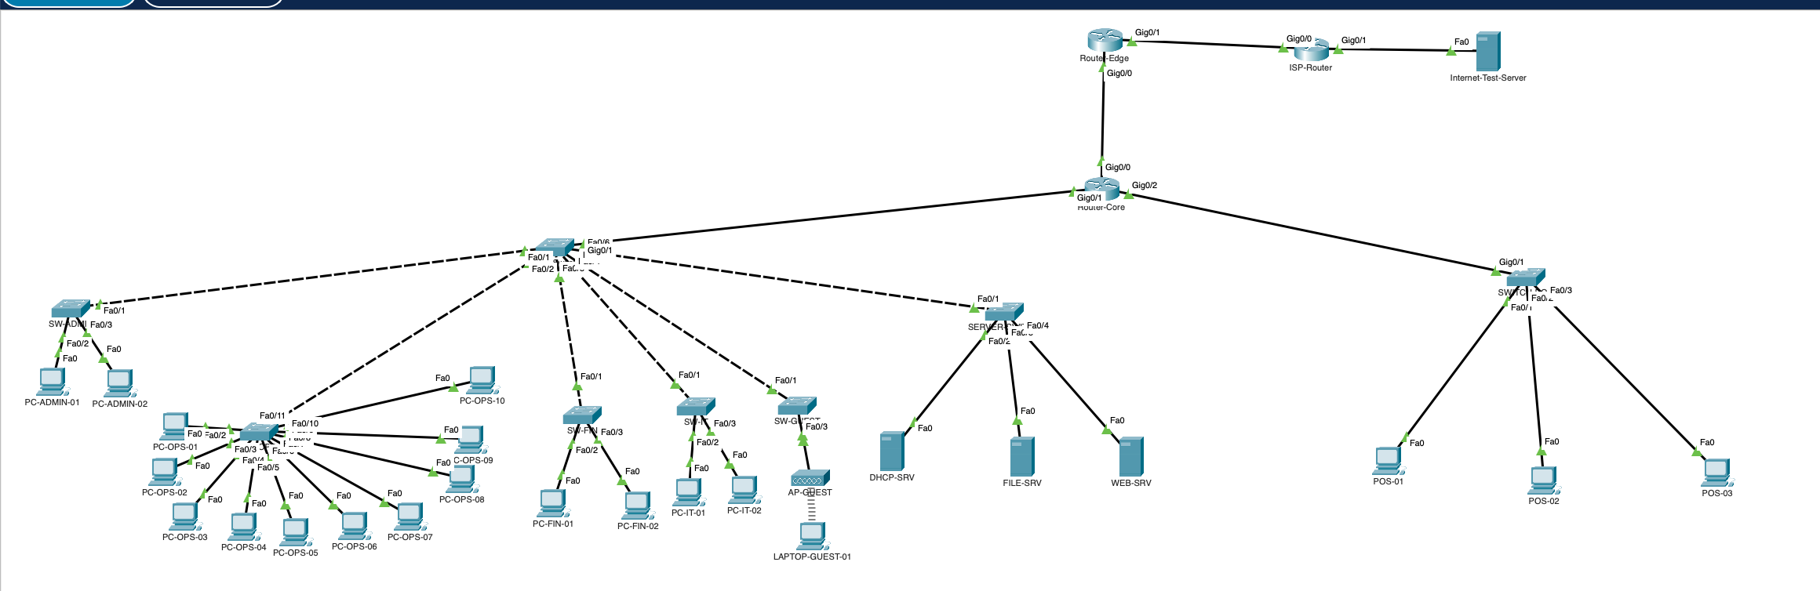
Figure 1. Final operational topology including the simulated internet. At the top Router-Edge connects to ISP-Router and Internet-Test-Server and, below it, to Router-Core; the office side hangs off Core-Switch on the left (SW-ADMIN, SW-OPS with PC-OPS-01 to PC-OPS-10, SW-FIN, SW-IT, SW-GUEST with AP-GUEST and LAPTOP-GUEST-01, SERVER-SWITCH with the three servers); the independent POS path runs from Router-Core Gi0/2 to SWITCH-POS on the right. Port labels are visible on every link and every link shows a green (up) indicator.

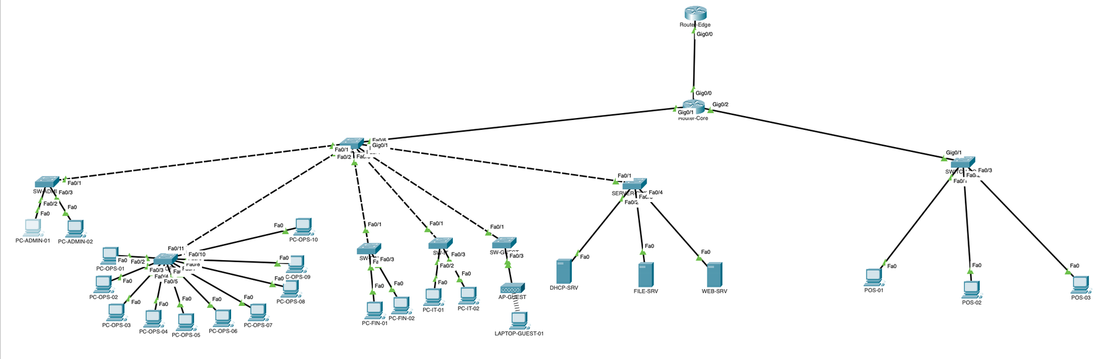
Figure 2. Detail of the office and POS network with port labels, captured before the simulated internet segment was added, showing the interface on each end of every link (Router-Core Gi0/0, Gi0/1 and Gi0/2; Core-Switch Fa0/1 to Fa0/6 and Gi0/1; SW-OPS Fa0/2 to Fa0/11; SERVER-SWITCH and SWITCH-POS access ports).

4 Implementation

4.1 Physical build
The physical topology was built first, before any configuration, so that cabling could be checked on its own. Figure 3 shows that stage: every device is placed and cabled, and the router-facing links still show red indicators because the router interfaces had not yet been enabled. At this point the guest laptop was still cabled to SW-GUEST by Ethernet; it was later moved to the wireless adapter so that it associates with AP-GUEST, as the finished topology in Figure 1 shows with the dotted wireless link. The simulated internet segment (ISP-Router and Internet-Test-Server) was added after this build stage and appears in Figure 1 and Section 5.6.
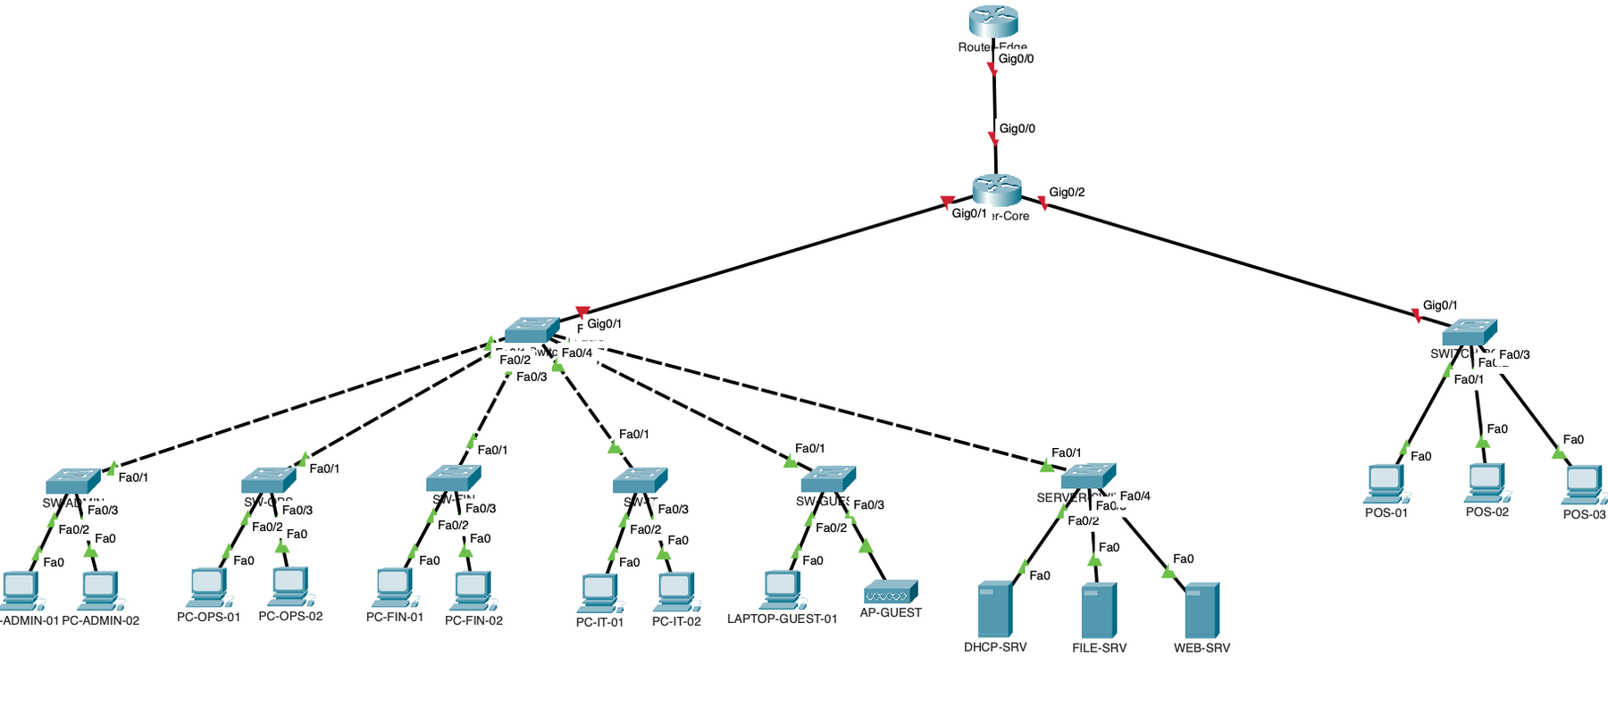
Figure 3. Initial physical build before configuration. All cabling is in place; the red indicators on the router links simply mean the interfaces were not yet enabled or addressed.

4.2 Layer 2: VLANs and trunks
Core-Switch holds all seven VLANs. VLAN names were chosen to match the client departments (Administration, Operations, Finance, IT_Technical, POS_Network, Guest_WiFi, Server_Infrastructure). Ports Fa0/1 to Fa0/6 toward the access switches, and Gig0/1 toward Router-Core, are 802.1Q trunks. The Gig0/1 trunk allows VLANs 10, 20, 30, 40, 60 and 70 only; VLAN 50 is left off on purpose because POS never uses that link. Every trunk uses the default native VLAN, 1, on both ends, which avoids the mismatch warnings described in Section 6.
Core-Switch(config)# vlan 10
Core-Switch(config-vlan)# name Administration
... same pattern for VLANs 20 Operations, 30 Finance, 40 IT_Technical,
50 POS_Network, 60 Guest_WiFi, 70 Server_Infrastructure
Core-Switch(config)# interface range FastEthernet0/1 - 6
Core-Switch(config-if-range)# switchport mode trunk
Core-Switch(config-if-range)# switchport trunk native vlan 1
Core-Switch(config-if-range)# switchport trunk allowed vlan 10,20,30,40,50,60,70
Core-Switch(config)# interface GigabitEthernet0/1
Core-Switch(config-if)# description Trunk to Router-Core (RoAS)
Core-Switch(config-if)# switchport mode trunk
Core-Switch(config-if)# switchport trunk allowed vlan 10,20,30,40,60,70
Core-Switch# write memory
Each departmental access switch follows one pattern. Fa0/1 is the trunk to Core-Switch, and the remaining ports are access ports in the department VLAN. SW-FIN is shown as the example; SW-ADMIN, SW-OPS and SW-IT are identical apart from the VLAN number (10, 20 and 40) and name.
SW-FIN(config)# vlan 30
SW-FIN(config-vlan)# name FINANCE
SW-FIN(config)# interface FastEthernet0/1
SW-FIN(config-if)# description Trunk to Core-Switch
SW-FIN(config-if)# switchport mode trunk
SW-FIN(config-if)# switchport trunk native vlan 1
SW-FIN(config-if)# switchport trunk allowed vlan 10,20,30,40,50,60,70
SW-FIN(config)# interface range FastEthernet0/2 - 24
SW-FIN(config-if-range)# switchport mode access
SW-FIN(config-if-range)# switchport access vlan 30
SW-FIN(config-if-range)# no shutdown
SW-FIN# write memory
SERVER-SWITCH uses a trunk on Fa0/1 toward Core-Switch (native VLAN 1, VLAN 70 allowed) and access ports in VLAN 70 for the three servers. SWITCH-POS is the exception described in Section 3.3: its three POS ports and its Gig0/1 uplink are all access ports in VLAN 50.
SWITCH-POS(config)# vlan 50
SWITCH-POS(config-vlan)# name POS_Network
SWITCH-POS(config)# interface range FastEthernet0/1 - 3
SWITCH-POS(config-if-range)# switchport mode access
SWITCH-POS(config-if-range)# switchport access vlan 50
SWITCH-POS(config)# interface GigabitEthernet0/1
SWITCH-POS(config-if)# description Dedicated uplink to Router-Core Gi0/2
SWITCH-POS(config-if)# switchport mode access
SWITCH-POS(config-if)# switchport access vlan 50
SWITCH-POS# write memory

4.3 Layer 3: Router-on-a-Stick on Router-Core
The physical interface GigabitEthernet0/1 has no IP address of its own; it simply has to be up. Each VLAN gets a sub-interface whose encapsulation dot1Q value matches the VLAN ID, and whose IP address is the gateway for that VLAN. The five sub-interfaces whose hosts use DHCP also carry the relay address of DHCP-SRV. Gi0/2 is a plain routed interface for POS.
Router-Core(config)# interface GigabitEthernet0/0
Router-Core(config-if)# ip address 10.48.0.2 255.255.255.252
Router-Core(config)# interface GigabitEthernet0/1
Router-Core(config-if)# no shutdown
Router-Core(config)# interface GigabitEthernet0/1.10
Router-Core(config-subif)# encapsulation dot1Q 10
Router-Core(config-subif)# ip address 10.48.10.1 255.255.255.0
Router-Core(config-subif)# ip helper-address 10.48.70.10
... .20 (10.48.20.1), .30 (10.48.30.1), .40 (10.48.40.1) and .60 (10.48.60.1)
follow the same pattern, each with encapsulation dot1Q <VLAN> and the helper
Router-Core(config)# interface GigabitEthernet0/1.70
Router-Core(config-subif)# encapsulation dot1Q 70
Router-Core(config-subif)# ip address 10.48.70.1 255.255.255.0
Router-Core(config)# interface GigabitEthernet0/2
Router-Core(config-if)# ip address 10.48.50.1 255.255.255.0
Router-Core(config-if)# no shutdown
Router-Core(config)# ip route 0.0.0.0 0.0.0.0 10.48.0.1
Router-Core# write memory
The default route in the last block was added later, when the simulated internet segment was built (Section 4.6). The complete running configurations of Router-Core, Core-Switch, SWITCH-POS, SW-FIN and SERVER-SWITCH are stored in the configs/ folder of the repository.

4.4 DHCP and server services
DHCP-SRV (10.48.70.10) runs the DHCP service with one pool per DHCP-served VLAN: Administration, Operations, Finance, IT and Guest. Every pool hands out addresses starting at .10 of its subnet with mask 255.255.255.0, the VLAN gateway as default gateway, and 10.48.70.10 as DNS server. WEB-SRV (10.48.70.12) serves the default Packet Tracer web page over HTTP, and FILE-SRV (10.48.70.11) is addressed and reserved for file and TFTP services. Because DHCP replies are relayed by Router-Core, a PC in any office VLAN can pick up an address from the central server, as the first DHCP lease of the project (Finance, 10.48.30.10) showed.

4.5 Change request CR1: Operations expansion
Operations began with PC-OPS-01 and PC-OPS-02. For CR1, eight more workstations (PC-OPS-03 to PC-OPS-10) were added to SW-OPS, giving ten Operations PCs on access ports Fa0/2 to Fa0/11. The access-port range on SW-OPS was already assigned to VLAN 20, so the new machines needed only a cable and a DHCP request. There is no new VLAN, no new subnet, no new gateway and no router change: the new hosts simply take the next free addresses in 10.48.20.0/24. That is what "capacity added without redesign" means in practice, and Figure 2 shows the ten PCs fanned out from SW-OPS.

4.6 Simulated internet segment
The client requirements ask for internet connectivity, so a simulated internet segment was added once the office and POS network was working. It was built last, and on Router-Edge's free interface, so that nothing already verified had to be reconfigured. Router-Edge keeps GigabitEthernet0/0 (10.48.0.1) toward Router-Core and uses GigabitEthernet0/1 to connect to ISP-Router Gi0/0. ISP-Router Gi0/1 then connects to Internet-Test-Server Fa0, which has the address 203.0.113.10 and serves the default Packet Tracer web page (Figure 12a).
The only change on the existing network was one command on Router-Core, a default route pointing at Router-Edge (10.48.0.1), shown in the configuration in Section 4.3 and in Figure 13. The tests that prove the segment works, by ping and by web browser, are in Section 5.6.

5 Verification and testing evidence
The tests below follow the layers of the network from the bottom up: VLANs and trunks, then routing, then host-to-host reachability, then services, then the scalability test. Where the first attempt of a test failed before succeeding, the screenshot shows both and Section 6 explains why.

5.1 VLAN and trunk verification
On SW-FIN, show vlan brief shows VLAN 30 (FINANCE) active on ports Fa0/2 to Fa0/24, and show interfaces trunk shows Fa0/1 trunking with 802.1Q encapsulation, native VLAN 1 and VLANs 10 to 70 allowed. The line "allowed and active in management domain" lists only VLAN 30, which is correct: an access switch only holds the VLANs created on it, and SW-FIN has only Finance.
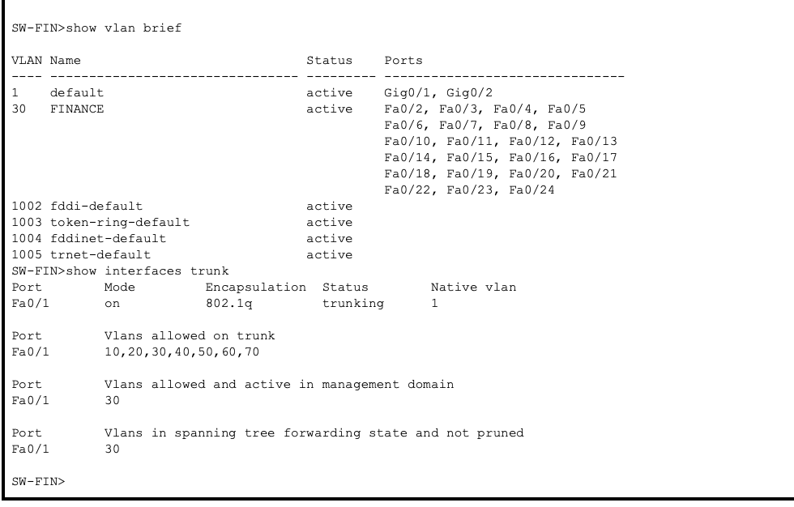
Figure 4. SW-FIN: VLAN 30 (FINANCE) on Fa0/2 to Fa0/24 and a single 802.1Q trunk on Fa0/1 with native VLAN 1 and VLANs 10,20,30,40,50,60,70 allowed.
On Core-Switch, show vlan brief lists all seven VLANs and show interfaces trunk shows Fa0/1 to Fa0/6 and Gig0/1 trunking. Gig0/1, the link to Router-Core, allows 10,20,30,40,60,70 and omits VLAN 50 as designed. This capture was taken before the final native VLAN fix and still contains %CDP-4-NATIVE_VLAN_MISMATCH messages for Fa0/6 and SERVER-SWITCH; they are the evidence for the fault described in Section 6.5, and the post-fix capture appears there.
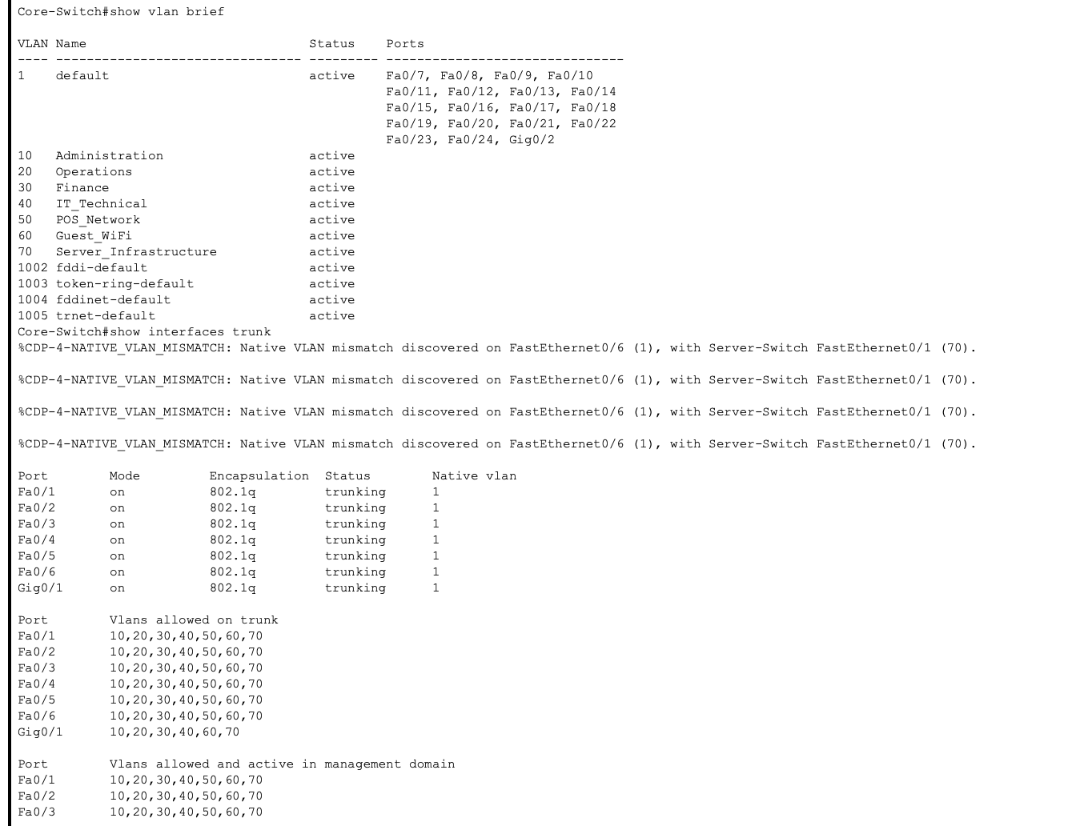
Figure 5. Core-Switch: seven VLANs and trunks on Fa0/1 to Fa0/6 and Gig0/1. The CDP native VLAN mismatch messages for Fa0/6 and SERVER-SWITCH Fa0/1 are visible and are the "before" evidence for Section 6.5.

5.2 Router-on-a-Stick verification
On Router-Core, show ip interface brief shows Gi0/0 (10.48.0.2), the unaddressed physical Gi0/1, sub-interfaces Gi0/1.10, .20, .30, .40, .60 and .70 with gateways 10.48.10.1 to 10.48.70.1, and Gi0/2 at 10.48.50.1, all up/up. Vlan1 is administratively down, which is expected on a router with no VLAN interface in use. The routing table lists each subnet as directly connected on the matching sub-interface, with POS (10.48.50.0/24) connected on the separate interface Gi0/2. The capture ends at the 10.48.50.0/24 entry; the table header reports 16 subnets, which accounts exactly for the connected and local entries of the remaining 10.48.50.1, 10.48.60.0 and 10.48.70.0 networks that were not scrolled into view.
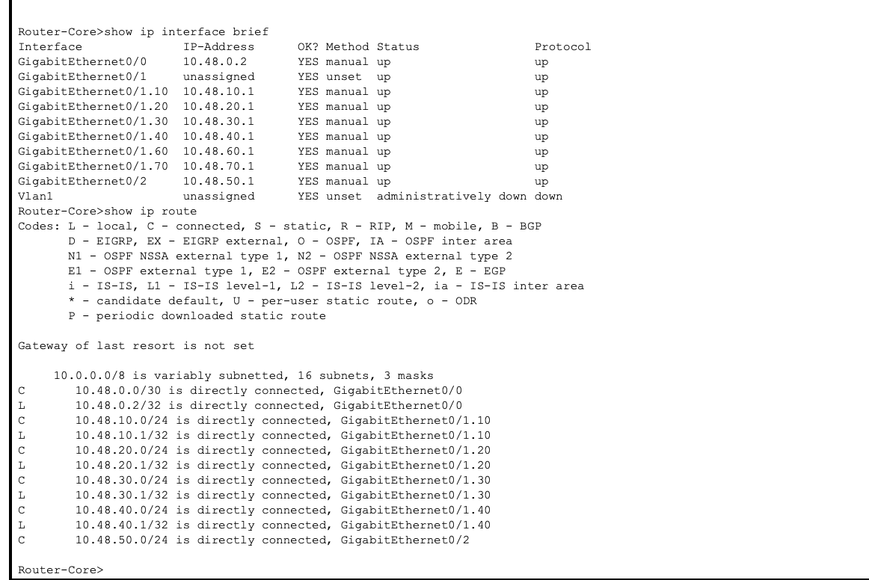
Figure 6. Router-Core: sub-interfaces Gi0/1.10 to Gi0/1.70 and Gi0/2 up/up with the correct gateways, and the connected routes for each subnet. No default route had been configured at the time of this capture; it is added in Section 5.6.

5.3 Same-VLAN and inter-VLAN connectivity
PC-FIN-01 pinged PC-FIN-02 (10.48.30.11) in the same VLAN. The first attempt timed out on all four packets and the second returned four replies at TTL 128, the unchanged TTL of a host on the same segment. I attribute the first-attempt failure to the duplicate DHCP lease problem described in Section 6.3.
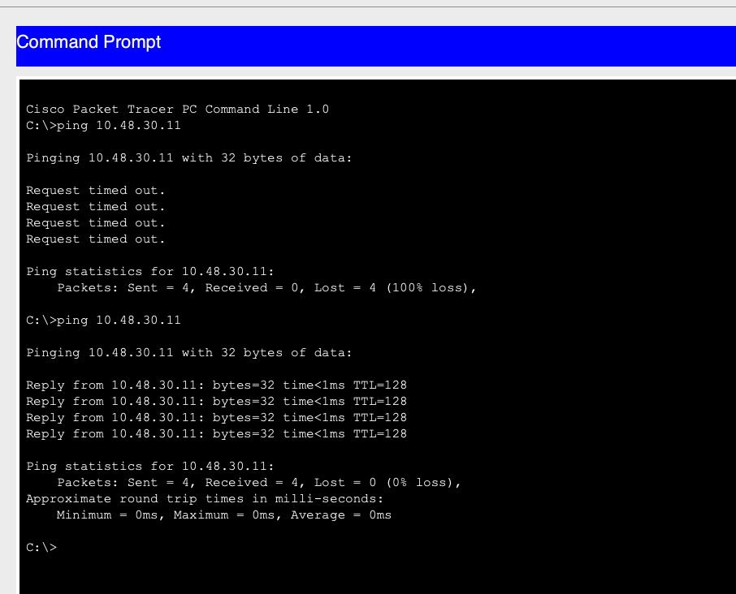
Figure 7. Same-VLAN test from PC-FIN-01 to 10.48.30.11: an initial failed attempt followed by 4/4 replies, 0% loss, TTL=128.
PC-FIN-01 then pinged 10.48.10.10 in a different VLAN. The first packet timed out while the router and host resolved each other with ARP; the remaining packets, and the whole second run, replied with TTL 127. TTL 127 is the proof that the packet crossed exactly one router: the destination decremented a starting value of 128 once. The address 10.48.10.10 belongs to PC-ADMIN-02, not PC-ADMIN-01, because DHCP hands out addresses in order of request (see Section 6.3).
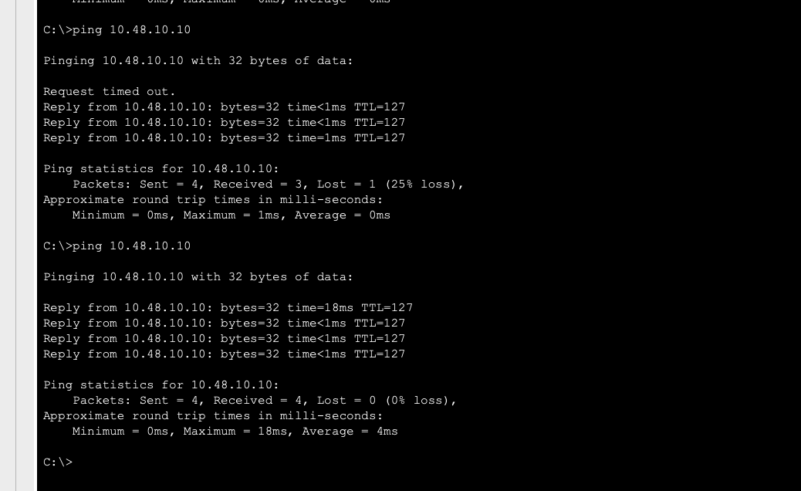
Figure 8. Inter-VLAN test from PC-FIN-01 (VLAN 30) to 10.48.10.10 (VLAN 10) through Router-Core: one ARP timeout, then replies with TTL=127; second run 4/4, 0% loss.

5.4 Service access and connectivity matrix
From an office workstation, the browser opened http://10.48.70.12 and loaded the default Packet Tracer page from WEB-SRV, proving routed HTTP access to the server VLAN.
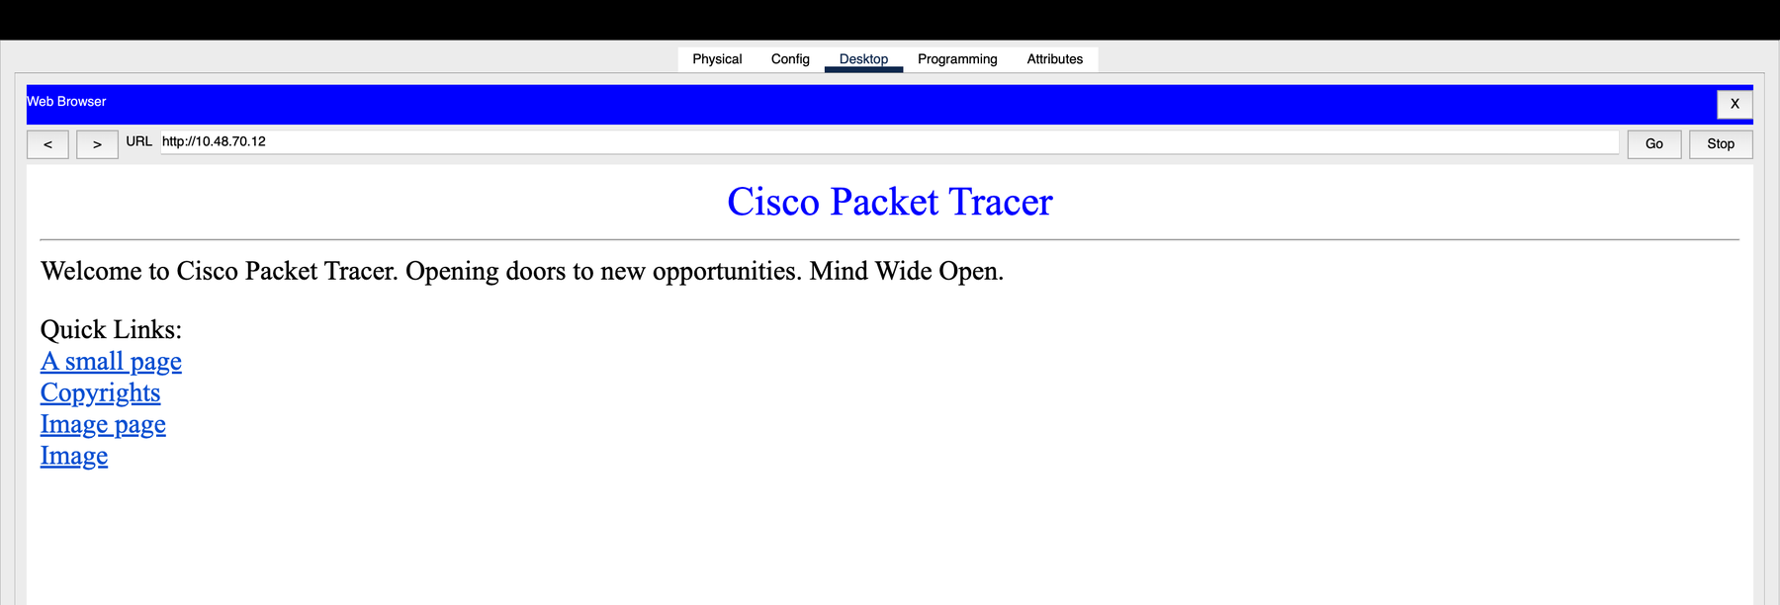
Figure 9. HTTP test: the web page served by WEB-SRV (10.48.70.12) rendered in an office workstation browser.
The connectivity matrix is run from PC-IT-01 against four targets: its own gateway (10.48.40.1), the server VLAN gateway (10.48.70.1), DHCP-SRV (10.48.70.10) and WEB-SRV (10.48.70.12). The first capture, Figure 10, shows the work in progress, including a mistake (several commands on one line, which the Packet Tracer prompt rejects) and DHCP-SRV answering unreliably on its first attempts. The final capture, Figure 11, shows all four targets at 0% loss.
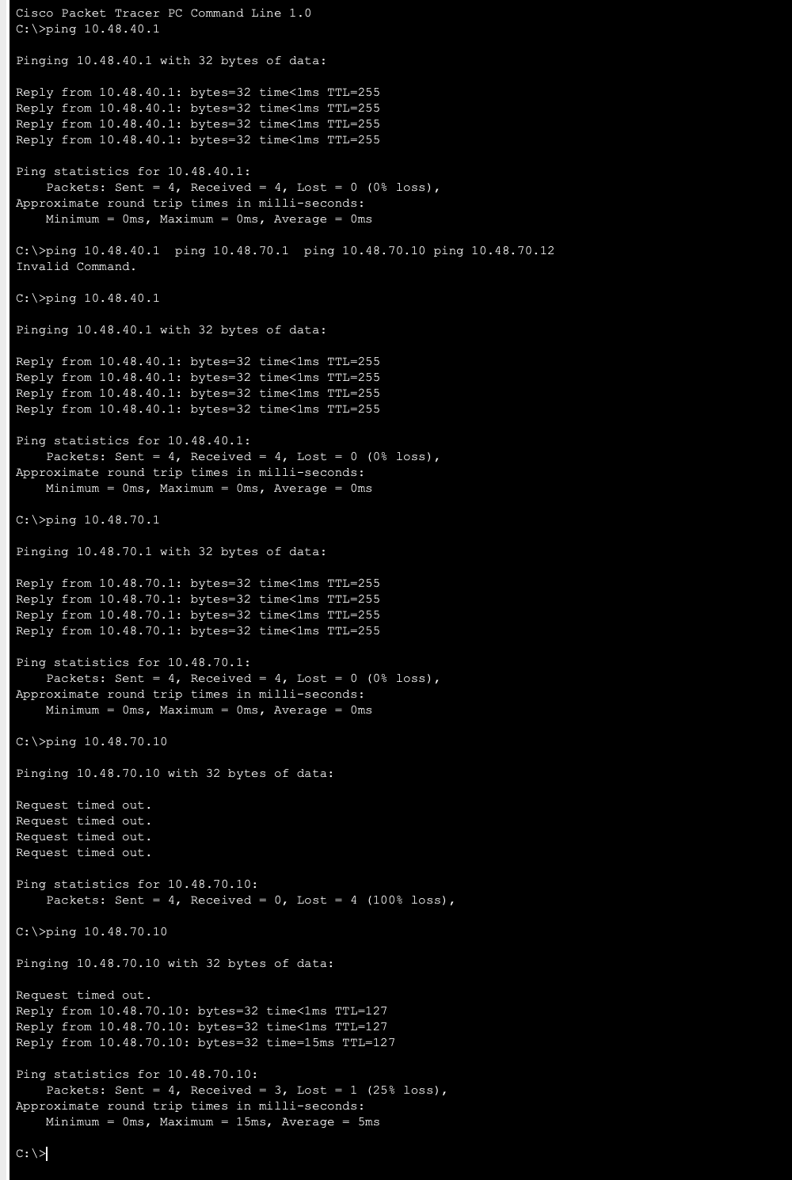  Figure 10. PC-IT-01, first attempts: gateway pings succeed; the combined-command line returns "Invalid Command"; 10.48.70.10 first shows 100% loss, then 25% loss. | 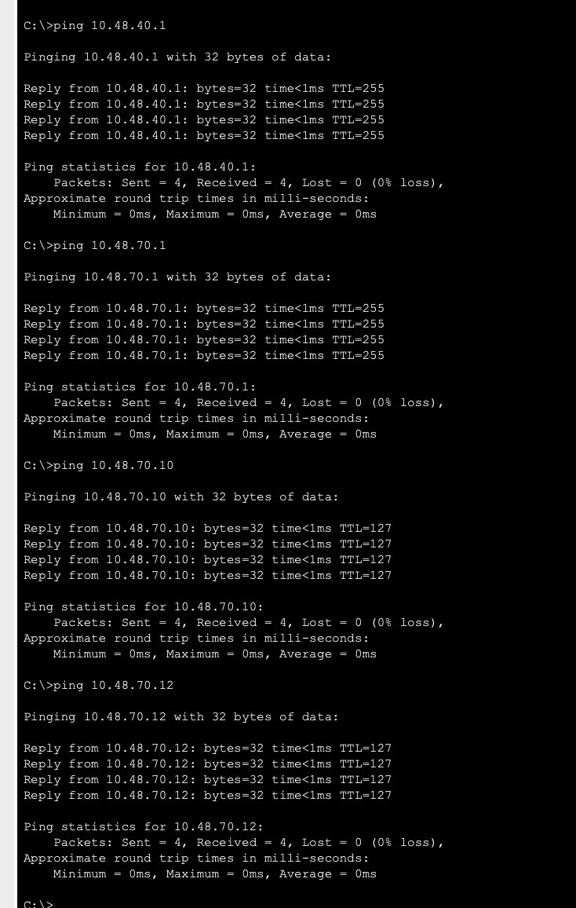  Figure 11. PC-IT-01 final matrix: 10.48.40.1, 10.48.70.1, 10.48.70.10 and 10.48.70.12 all reply, 4/4, 0% loss.

5.5 CR1 scalability evidence
PC-OPS-10, the last of the eight added workstations, obtained an address in 10.48.20.0/24 and pinged WEB-SRV (10.48.70.12) across subnets. The first packet timed out for ARP and the second run replied 4/4, TTL 127. This shows that a host added without any configuration change on the router or core is fully functional on its existing VLAN.
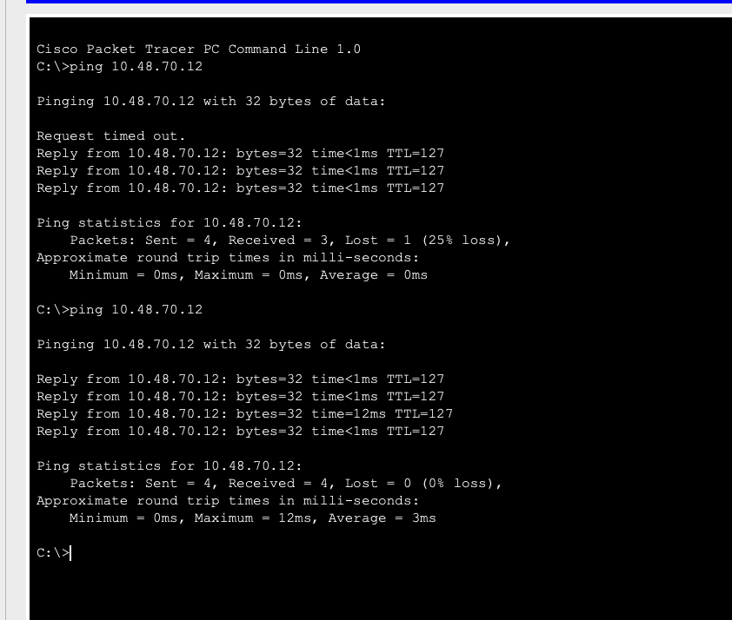
Figure 12. CR1: PC-OPS-10 reaching WEB-SRV across VLANs: one ARP timeout, then replies at TTL=127; second run 4/4, 0% loss.

5.6 Simulated internet connectivity
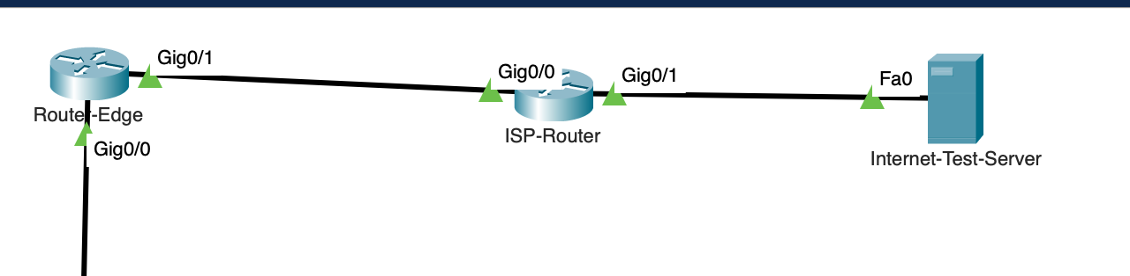
Figure 12a. The simulated internet segment added after Figure 2 was captured: Router-Edge Gig0/1 to ISP-Router Gig0/0, and ISP-Router Gig0/1 to Internet-Test-Server Fa0, with green (up) indicators on every link.
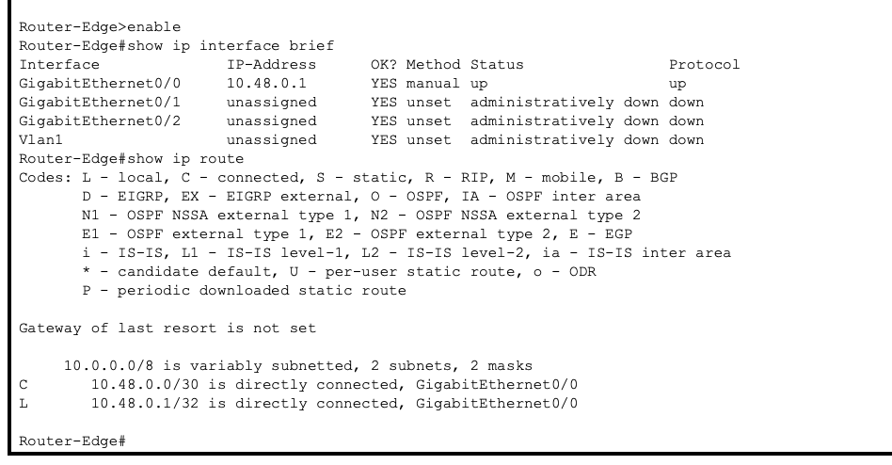
Figure 12b. Router-Edge before the internet link was configured: Gi0/0 (10.48.0.1) up/up toward Router-Core, Gi0/1 administratively down and therefore the free interface used for the ISP-Router link, and no gateway of last resort yet. This capture confirms the interface identified in the planning step before any commands were pasted.
Figure 12a shows the simulated internet segment that this section tests, and Figure 12b confirms that Router-Edge GigabitEthernet0/1 was the free interface used for the new link. The segment was planned so that no existing working interface had to be reconfigured.
The client requirements ask for internet connectivity, which I simulated in Packet Tracer. Router-Edge connects through GigabitEthernet0/1 to ISP-Router, and ISP-Router connects to Internet-Test-Server, a web server with the address 203.0.113.10. On Router-Core I added a default route pointing at Router-Edge's address on the point-to-point link, 10.48.0.1, so that every destination outside the office subnets is sent toward the edge (Figure 13).
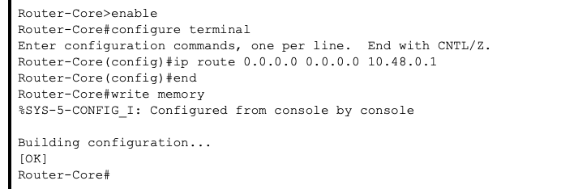
Figure 13. Router-Core: default route to Router-Edge (ip route 0.0.0.0 0.0.0.0 10.48.0.1), saved with write memory.
From an office client I then pinged the test server (Figure 14). The first attempt lost three of the four packets, which I put down to the new path still being resolved, and the repeat succeeded with 4 of 4 replies and 0% loss. The reply TTL of 125 shows that the packets crossed three routers on the way back, namely ISP-Router, Router-Edge and Router-Core, since the server starts from 128.
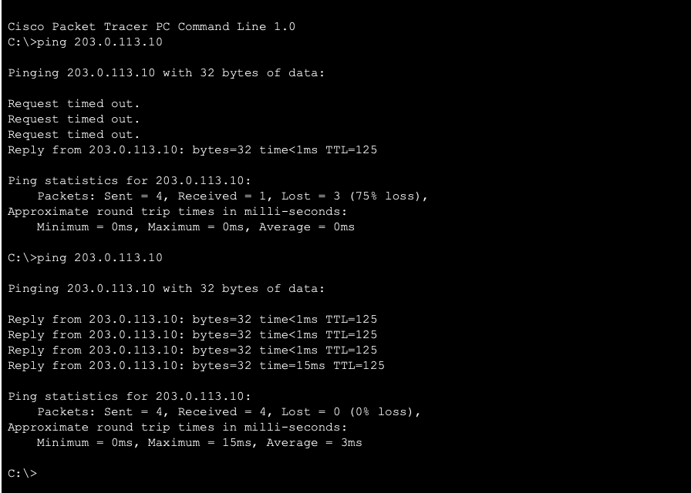
Figure 14. Ping from an office client to 203.0.113.10: first attempt 1 of 4 replies (75% loss), repeat 4 of 4 replies (0% loss), TTL 125.
Finally, a web browser on the client loaded http://203.0.113.10 and displayed the default Packet Tracer page (Figure 15), which shows that an application-layer service works across the same path and not only ICMP.
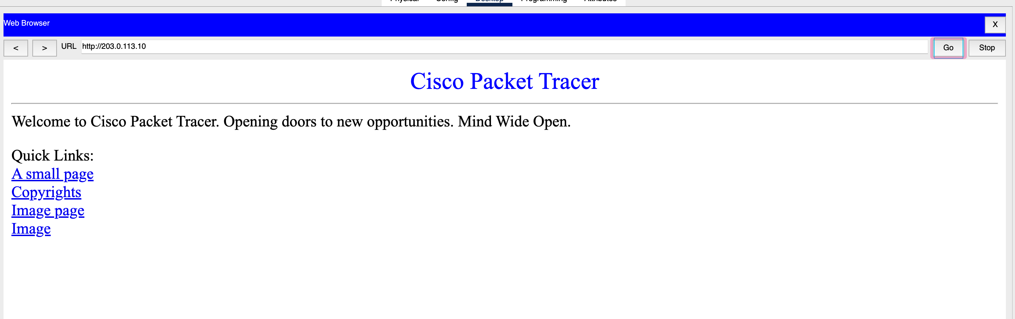
Figure 15. Web browser on an office client loading http://203.0.113.10 from Internet-Test-Server.
This is a simulated internet and nothing more: it shows that the office network can reach a server beyond Router-Edge, not that the design connects to a real WAN. The POS terminals were not tested against it, and the CR2 result in Section 7 is still limited to POS reachability of its own gateway and peers.

6 Troubleshooting record
This section is the chronological record of what went wrong and how each problem was found and fixed. Most of the effort of this project went here, and almost every fault was a configuration mismatch between two ends of a link rather than a missing feature.

6.1 Packet Tracer Note tool triggered by a keyboard shortcut
While fast-forwarding time to let Spanning Tree settle, I pressed the Fast Forward shortcut (Alt+N, Option+N on the Mac) too many times. On macOS that shortcut places a Note in the workspace, so afterwards every click on the canvas opened a text box asking for a note. Nothing was broken. Pressing Esc, or clicking the Select tool, returned the cursor to normal. From then on I used the on-screen Fast Forward button instead of the keyboard shortcut.

6.2 DHCP failure: a chain of faults, not a single one
The first symptom was that PC-FIN-01 fell back to an automatic private address (169.254.x.x), which means its DHCP request never received an answer. A DHCP request is a chain: PC to access port, access switch, trunk, core switch, trunk, router sub-interface, relay, server, and back. Any one broken link looks identical from the PC. I found four separate faults on that chain, and fixing only one at a time made it look as if nothing had changed.
Fault A: missing VLANs and unassigned ports. My first assumption was that the VLANs did not exist on the switches, since a switch drops frames tagged for a VLAN it does not know. I created the VLANs on Core-Switch and the access switch and assigned the PC ports. DHCP still failed. At that point I paused DHCP deliberately so that the other phases of the build plan (switching verification, Router-on-a-Stick and addressing) could move forward, and then returned to it as its own phase with a systematic checklist of the whole chain. Those other phases later verified correctly (Section 5).
Fault B: uplinks configured as access ports. When I configured SW-IT, I applied the access-port range to Fa0/1, but Fa0/1 is the cable to Core-Switch. Spanning Tree immediately complained:
%SPANTREE-2-RECV_PVID_ERR: Received 802.1Q BPDU on non trunk FastEthernet0/1 VLAN1.
%SPANTREE-2-BLOCK_PVID_LOCAL: Blocking FastEthernet0/1 on VLAN0001. Inconsistent port type.
Core-Switch was sending trunk frames into an access port, so Spanning Tree blocked the port, and with the only uplink blocked, no DHCP traffic could leave the switch. The fix on every department switch was to make Fa0/1 a trunk and move the PC ports to Fa0/2 and above.
Fault C: native VLAN mismatches on the department uplinks. Once the ports were trunks, the consoles of SW-IT, SW-ADMIN, SW-OPS and SW-FIN repeated native VLAN warnings, for example:
%CDP-4-NATIVE_VLAN_MISMATCH: Native VLAN mismatch discovered on FastEthernet0/1 (40),
with Core-Switch FastEthernet0/4 (1).
The department-switch ports still carried their access VLAN (40, 10, 20, 30) as the untagged VLAN, while the Core-Switch ends used native VLAN 1. I set both ends of every uplink to switchport trunk native vlan 1 with VLANs 10 to 70 allowed, and the warnings stopped.
Fault D: the wrong subnet mask on the servers. The server screenshots showed a subnet mask of 255.0.0.0 on DHCP-SRV, FILE-SRV and WEB-SRV, which is the default Class A mask Packet Tracer fills in. With that mask a server believes the whole of 10.0.0.0/8 is local, so it ARPs for off-subnet addresses instead of sending them to its gateway and cross-VLAN communication breaks. I changed all three to 255.255.255.0 with gateway 10.48.70.1, and also checked SERVER-SWITCH so that Fa0/2 to Fa0/4 were access ports in VLAN 70.
After all four faults were fixed, PC-FIN-01 requested an address again and received 10.48.30.10 with gateway 10.48.30.1 and DNS server 10.48.70.10. That was the first end-to-end DHCP success of the project.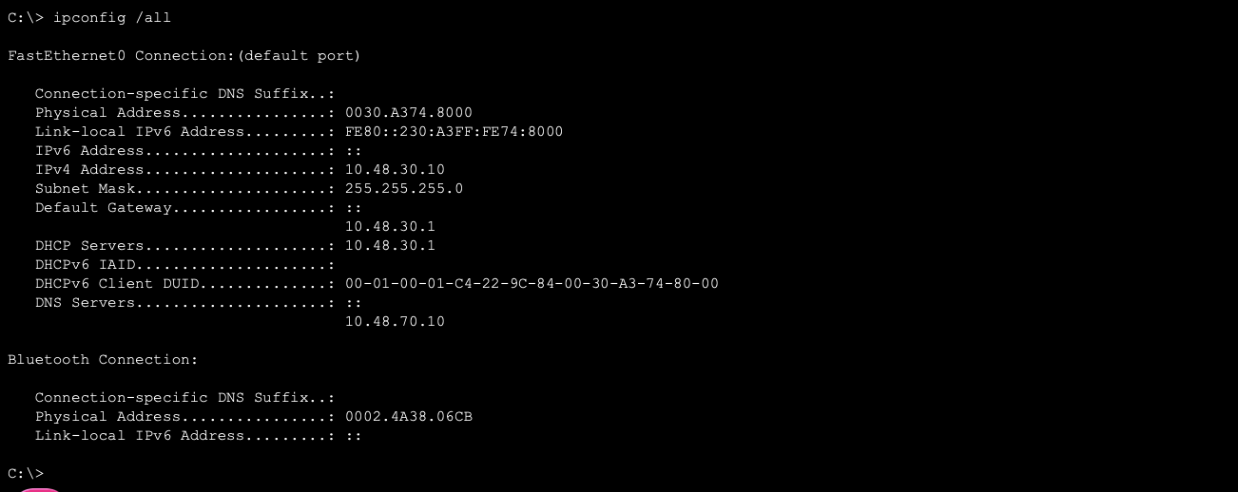
Figure 16 confirms the result from the client side. Running ipconfig /all on PC-FIN-01 shows an IPv4 address of 10.48.30.10, mask 255.255.255.0, default gateway 10.48.30.1 and DNS server 10.48.70.10, all received by DHCP with no static entry. The DHCP Servers field lists 10.48.30.1, the Finance gateway on Router-Core, and not DHCP-SRV's own address 10.48.70.10. The screenshot does not show the relay itself, but the result is consistent with the design: DHCP-SRV is the only DHCP server in the network, its pool supplies the DNS address 10.48.70.10 seen here, and the Finance sub-interface forwards requests to it with ip helper-address, so the client reports the relay interface it communicated with.
Figure 16. DHCP lease on PC-FIN-01 after the fixes: 10.48.30.10/24, gateway 10.48.30.1, DNS 10.48.70.10.

6.3 Duplicate DHCP leases and the order of addresses
Even after DHCP worked, pings between PC-FIN-01 and PC-FIN-02 failed on the first run (the first capture in Figure 7), and several PCs appeared to share the same address. The most likely cause was stale lease bindings on DHCP-SRV left over from the earlier failed attempts; I did not isolate it further, because clearing the bindings resolved it. I cleared them by turning the DHCP service off and on again on DHCP-SRV, then switching each PC from Static back to DHCP so that it sent a fresh request. After that every PC held a distinct address, and the Finance ping succeeded.
One side-effect is worth recording so that it does not look like a mistake: PC-ADMIN-02 holds 10.48.10.10 and PC-ADMIN-01 holds .11, and the same swap occurred in Operations. DHCP hands out the next free address to whichever PC asks first, so the number does not follow the host name. It has no effect on routing, but it explains why a ping to 10.48.10.10 reached PC-ADMIN-02.

6.4 First-attempt ping failures, ARP, and Packet Tracer command-line limits
A first ping between hosts that have never talked often loses its first packet, because the sender must ARP for the target first and Packet Tracer times the packet out while it waits. This explains the single lost packet in Figure 8 and Figure 12. It does not explain whole runs of four timeouts, which indicate a real fault, as in Figure 7 (duplicate leases) and the first DHCP-SRV attempts in Figure 10. For DHCP-SRV I rechecked that its port was in VLAN 70, that its static address and gateway were correct, and let the topology settle; it then answered every packet (Figure 11).
Three Packet Tracer command-prompt limits also cost time. The PC prompt rejects several commands on one line ("Invalid Command", visible in Figure 10), does not support the -t continuous-ping flag (Figure 19), and does not accept pasted text in its terminal, so each ping has to be typed on its own line.

6.5 Native VLAN mismatch between Core-Switch Fa0/6 and SERVER-SWITCH Fa0/1
One mismatch survived the department-switch fixes. Core-Switch kept logging:
%CDP-4-NATIVE_VLAN_MISMATCH: Native VLAN mismatch discovered on FastEthernet0/6 (1),
with Server-Switch FastEthernet0/1 (70).
The wording of the message identifies which side is wrong. The local port, Core-Switch Fa0/6, reports native VLAN 1; the neighbour, SERVER-SWITCH Fa0/1, reports native VLAN 70. Core-Switch was therefore already correct and the fix belonged on SERVER-SWITCH, where I set switchport trunk native vlan 1 on Fa0/1 so that both ends use VLAN 1. (A mismatch matters because untagged frames on a trunk are placed in the native VLAN, so unequal values can leak or mislabel traffic between VLANs.) The "before" state is visible in Figure 5. The captures below show the corrected state.
SERVER-SWITCH(config)# interface FastEthernet0/1
SERVER-SWITCH(config-if)# switchport mode trunk
SERVER-SWITCH(config-if)# switchport trunk native vlan 1
SERVER-SWITCH(config-if)# switchport trunk allowed vlan 70
SERVER-SWITCH# write memory
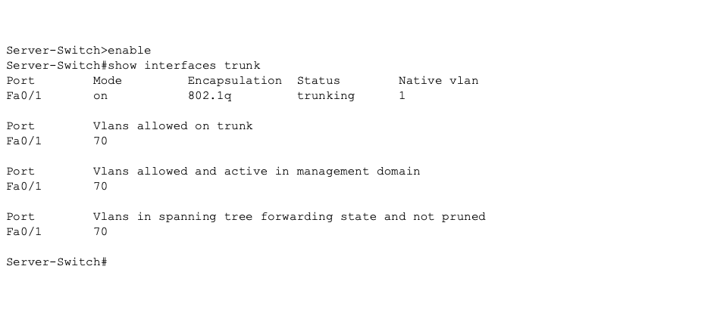
Figure 17 shows the corrected trunk on SERVER-SWITCH. Fa0/1 is trunking with 802.1Q encapsulation and native VLAN 1, which now matches Core-Switch Fa0/6. Only VLAN 70 is allowed, active and forwarding on the trunk, which is exactly right for a switch that holds only the server VLAN.
Figure 17. SERVER-SWITCH show interfaces trunk after the native VLAN fix: Fa0/1 trunking, 802.1Q, native VLAN 1, VLAN 70 only.
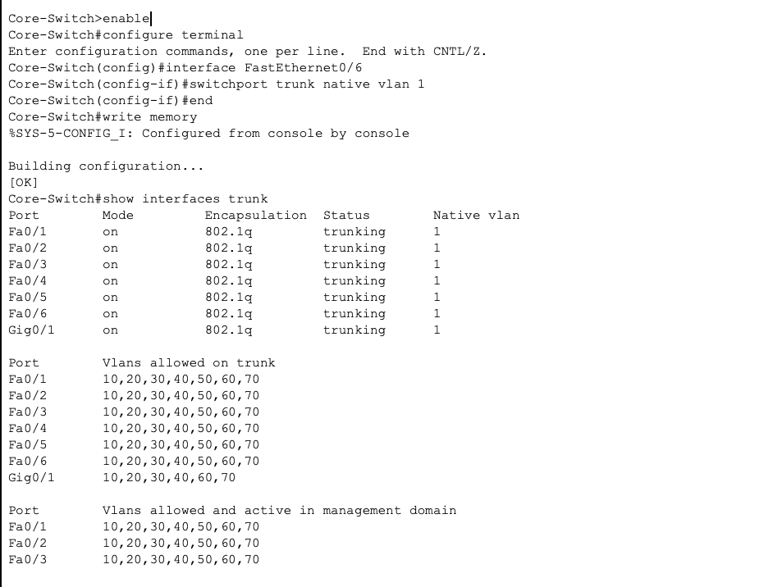
Figure 18 shows the corrective command on Core-Switch (switchport trunk native vlan 1 on Fa0/6, then write memory) followed by show interfaces trunk. All seven trunks, Fa0/1 to Fa0/6 and Gig0/1, are trunking with 802.1Q and native VLAN 1. Fa0/1 to Fa0/6 allow VLANs 10 to 70, while Gig0/1 toward Router-Core allows 10, 20, 30, 40, 60 and 70 and leaves out VLAN 50 as designed. The list of VLANs allowed and active in the management domain is cut off after Fa0/3 by the size of the terminal window.
Figure 18. Core-Switch after the native VLAN fix: every trunk on native VLAN 1; Gig0/1 omits VLAN 50 by design.

6.6 The first POS resilience test, and why it was the wrong test
The first attempt at the resilience requirement was an individual-link test. I confirmed that POS-01 could reach the gateway 10.48.50.1, then shut down FastEthernet0/1 on SWITCH-POS, which is the access port that POS-01 plugs into. Pinging then failed as expected. Figure 20 captures the moment: the top part shows show vlan brief on SWITCH-POS (VLAN 50 holds Fa0/1, Fa0/2, Fa0/3 and Gig0/1, so the VLAN configuration was never the fault), and the bottom part shows the shutdown command being entered.
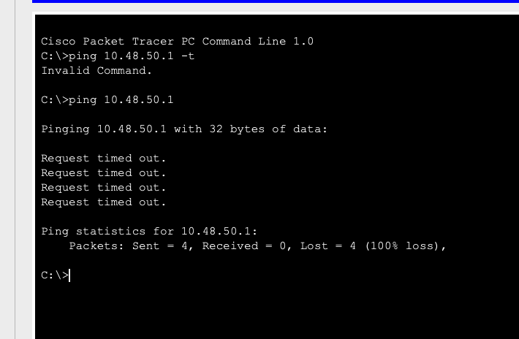
Figure 19. POS-01 after the port was shut down: "ping 10.48.50.1 -t" rejected as Invalid Command, then 100% loss.
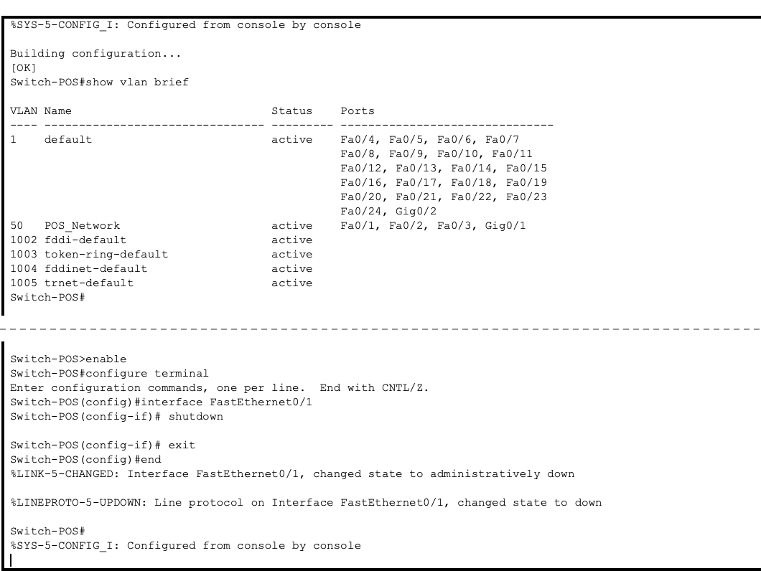
Figure 20. SWITCH-POS: VLAN 50 (POS_Network) on Fa0/1, Fa0/2, Fa0/3 and Gig0/1 (top); the deliberate shutdown of FastEthernet0/1 (bottom).
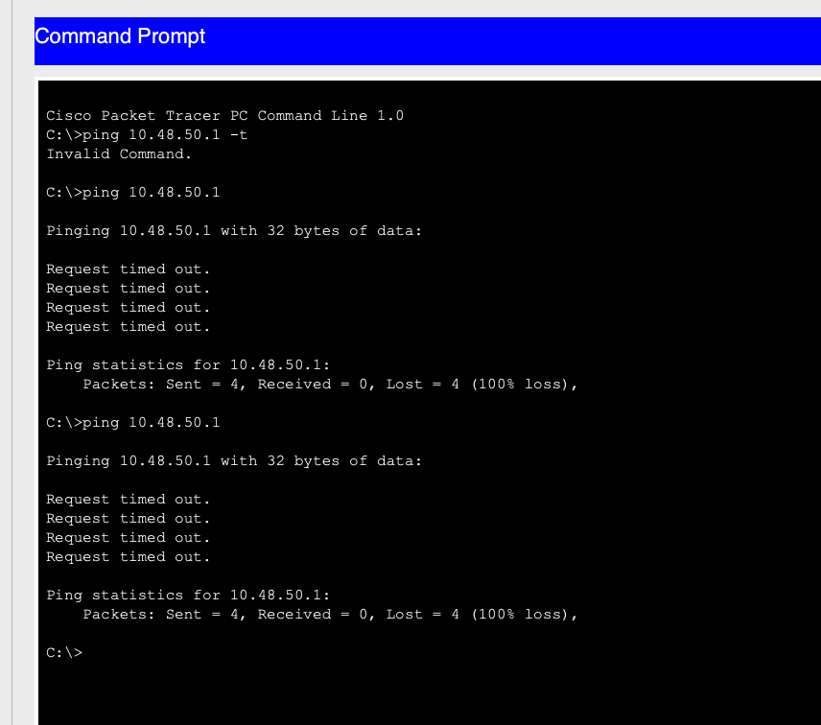
Figure 21. POS-01 repeated pings to 10.48.50.1 while the port was down: 100% loss each time.
I restored the port with no shutdown and saved the configuration (Figure 22). The topology showed every POS-side link green again (Figure 23), but POS-01 still failed several attempts in a row (Figure 24). It answered only after I re-enabled DHCP on POS-01 so that it requested a fresh address, after which the gateway replied 4/4 (Figure 25).
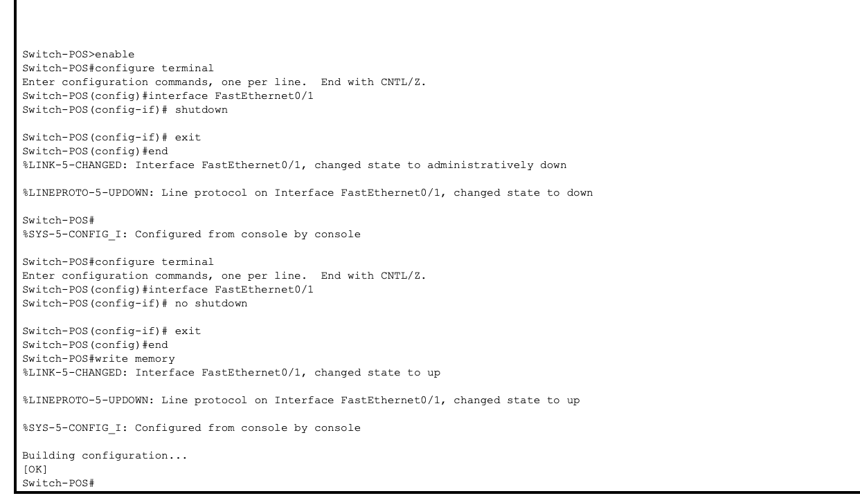
Figure 22. SWITCH-POS CLI: shutdown of FastEthernet0/1, then no shutdown, then write memory ([OK]); the log shows the interface changing to administratively down and back up.
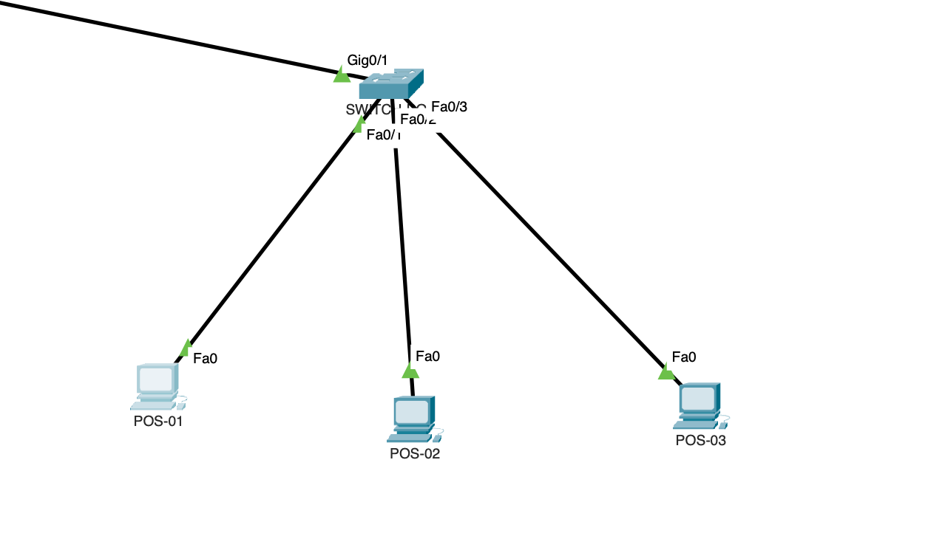
Figure 23. SWITCH-POS after restoration: the uplink Gig0/1 and the POS ports Fa0/1, Fa0/2 and Fa0/3 all show green link indicators.
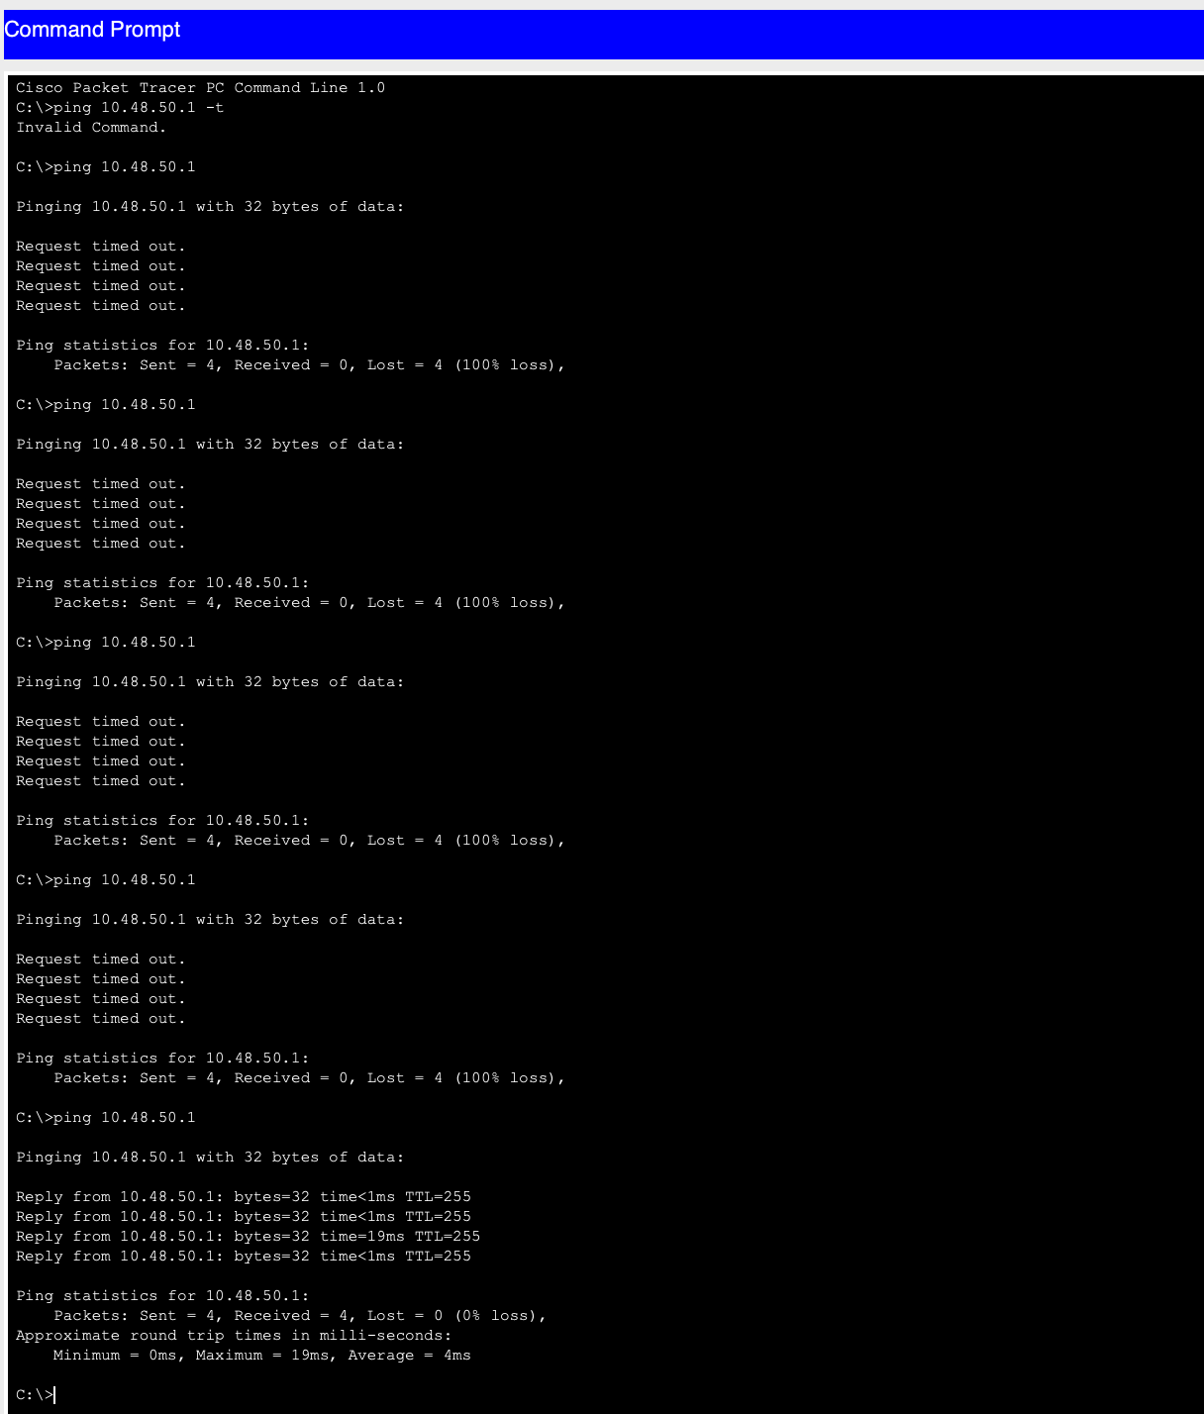
Figure 24. POS-01 ping history: the invalid -t flag, four consecutive 100%-loss runs, then a successful run once its address was refreshed.
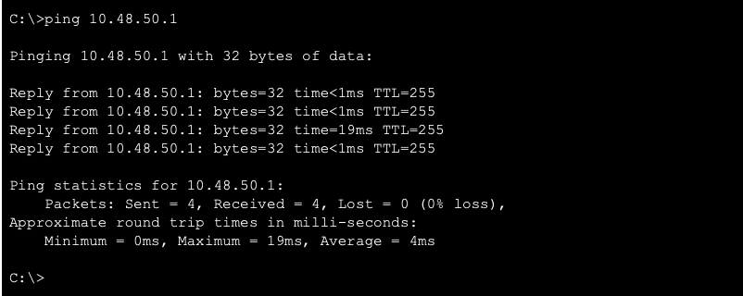
Figure 25. POS-01 to 10.48.50.1 after recovery: 4/4 replies, TTL=255, 0% loss.
What this test proved, and what it did not. It proved that a single POS access link can fail and be restored, and it exposed that a terminal may need its address refreshed after a link bounce. It did not prove the client constraint, because the office LAN stayed up the whole time, and it shut down the wrong interface for that purpose. In the report and the repository it is therefore called the individual POS link failure and recovery test, and not the CR2 test. The real constraint test follows.

7 Constraint CR2: POS resilience test

7.1 What is being proved
The constraint says POS must stay online if the office LAN fails. The design answer is that the office LAN depends on Router-Core Gi0/1 and everything behind it, while POS depends only on Router-Core Gi0/2 and SWITCH-POS. The test therefore removes the office LAN by shutting down Gi0/1 and checks two things at once: POS continues to work, and the office really is down. The second check matters, because evidence that POS works is only meaningful if the office failure actually happened.

7.2 Procedure and evidence
Step 1: baseline. With everything healthy, POS-01 pinged its gateway 10.48.50.1 and the peer terminal 10.48.50.12 (POS-03). The gateway answered 4/4. The first ping to .12 timed out entirely and the second returned 4/4 at TTL 128; the failed run was most likely lost to initial address resolution, because the destination was not yet in the ARP cache.
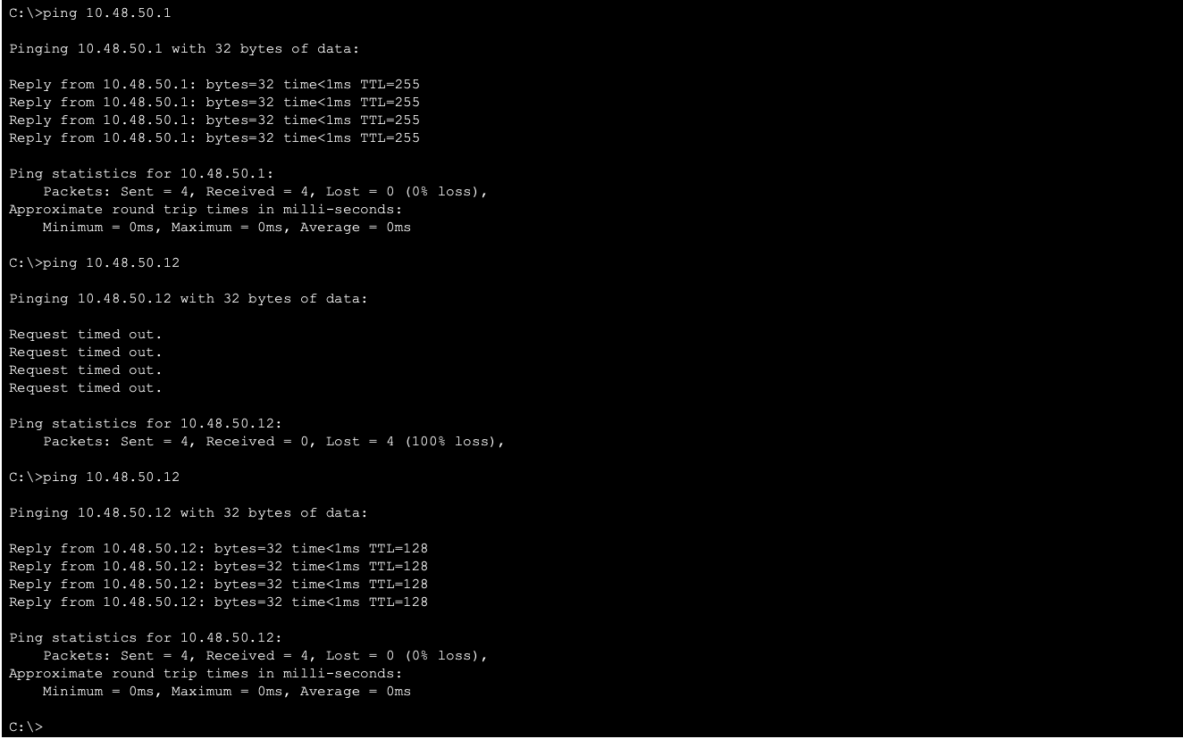
Figure 26. Baseline before the failure: POS-01 to 10.48.50.1 4/4 replies; to 10.48.50.12 one failed run, then 4/4 replies.
Step 2: a privilege-mode mistake. Router-Core was at the user prompt (Router-Core>), so configure terminal and interface g0/1 were rejected with "Invalid input detected at '^' marker", and shutdown was treated as a host name that IOS tried to resolve through DNS ("Translating 'shutdown'... domain server"). Configuration commands only exist in privileged mode; I typed enable first.
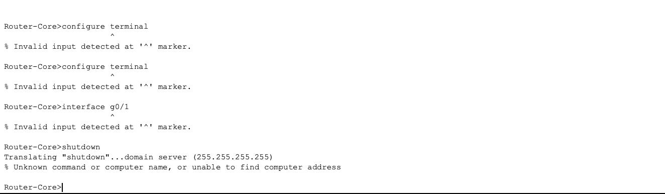
Figure 27. Router-Core at the user EXEC prompt (>): configure terminal, interface g0/1 and shutdown all rejected or misread as host names.
Step 3: take the office LAN down. From privileged mode I shut down only Gi0/1. The log shows Gi0/1 going administratively down and all six sub-interfaces (.10, .20, .30, .40, .60, .70) following it. Gi0/2 does not appear, because it was deliberately left up.
Router-Core> enable
Router-Core# configure terminal
Router-Core(config)# interface g0/1
Router-Core(config-if)# shutdown
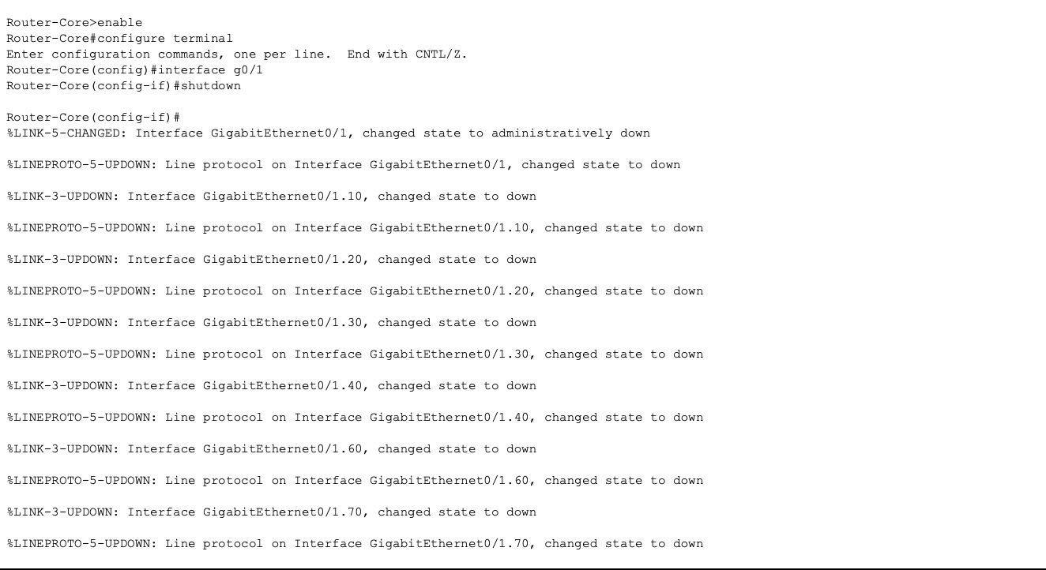
Figure 28. Router-Core: Gi0/1 administratively down, with sub-interfaces Gi0/1.10, .20, .30, .40, .60 and .70 all changing to down. Gi0/2 is untouched.
Step 4: POS keeps working. While Gi0/1 was down, POS-01 pinged 10.48.50.1 and received four replies at TTL 255 (the router itself, reached through Gi0/2). It then pinged 10.48.50.12 and received four replies at TTL 128. One command was typed without the word "ping" and rejected as Invalid Command; the retyped command succeeded. The topology confirms the picture: the link between Router-Core and Core-Switch is red while the Router-Core to SWITCH-POS link is green.
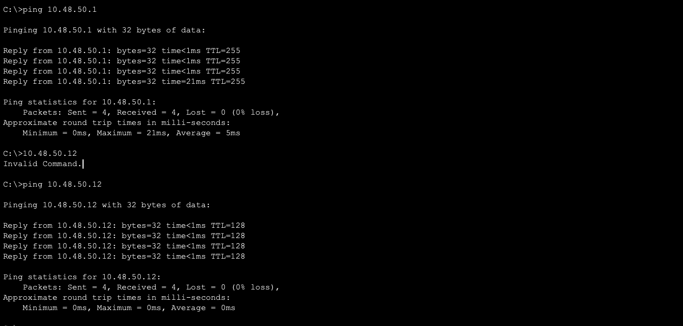
Figure 29. During the office outage: POS-01 gets 4/4 replies from 10.48.50.1 (TTL 255) and 4/4 from 10.48.50.12 (TTL 128), 0% loss.
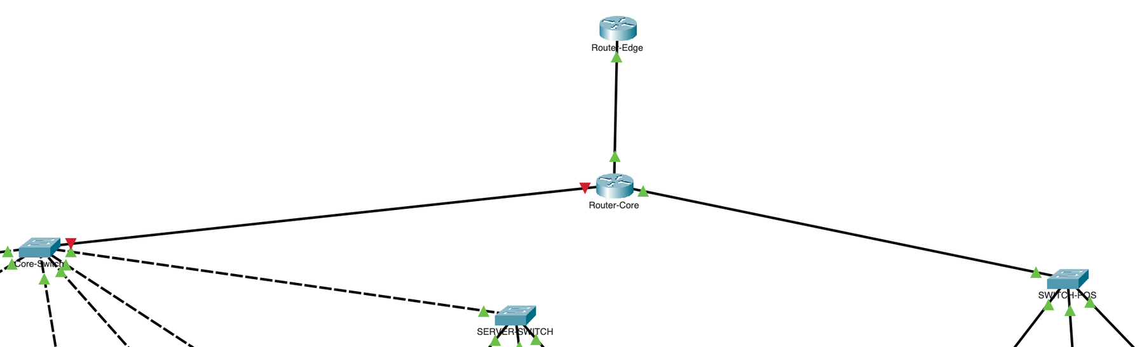
Figure 30. Topology during the outage: red indicators on Router-Core Gi0/1 and Core-Switch Gi0/1 (the office trunk); the POS link and all POS ports remain green.
Step 5: the office is genuinely down. From the Finance workstation PC-FIN-01, a ping to its own gateway 10.48.30.1 failed on all four packets, 100% loss. The sub-interface that provides that gateway is down, so this is the contrast that makes the POS result meaningful.
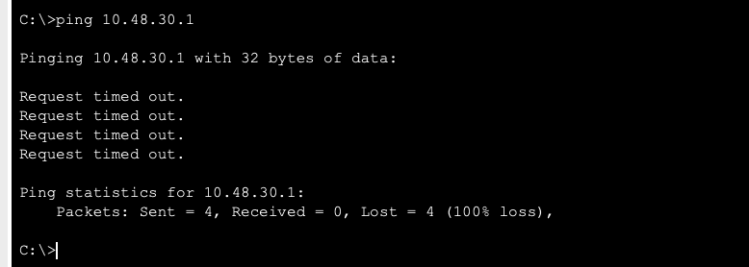
Figure 31. During the outage: PC-FIN-01 cannot reach its gateway 10.48.30.1, 4/4 timeouts, 100% loss.
Step 6: restore. I re-enabled Gi0/1 with no shutdown and ran show ip interface brief. The log shows Gi0/1 coming up and the line protocol of all six sub-interfaces returning to up, and the table shows Gi0/1 and every sub-interface up/up, with Gi0/2 still up/up at 10.48.50.1.
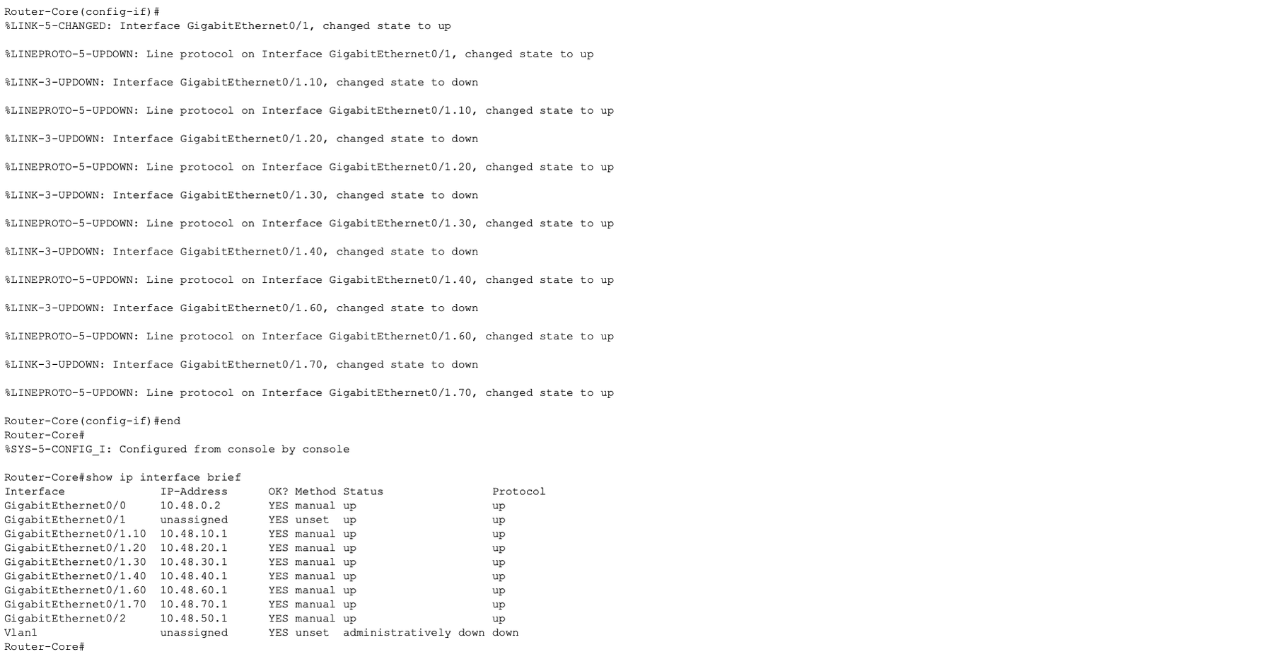
Figure 32. Restoration: Gi0/1 and sub-interfaces .10 to .70 back to up/up; Gi0/2 unchanged at 10.48.50.1.

7.3 Extended CR2 test: POS external reachability during an office outage
The CR2 test in Section 7.2 proves that POS keeps its gateway and its peers while the office trunk is down. Because Router-Core reaches the simulated internet through GigabitEthernet0/0 and Router-Edge, neither of which the office-trunk failure touches, the same failure can be used to test the external server. The planned procedure is: (1) with the network healthy, ping 203.0.113.10 from POS-01 and confirm replies; (2) shut down only Router-Core Gi0/1 exactly as in Section 7.2; (3) from POS-01 repeat both ping 10.48.50.1 and ping 203.0.113.10; (4) from PC-FIN-01 repeat ping 10.48.30.1 to confirm the office side is still down; (5) restore with no shutdown and confirm Gi0/1 and the office sub-interfaces return to up/up.
Routing prerequisites: Router-Edge must hold a route to 203.0.113.0/24 (or a default route) via ISP-Router, and ISP-Router must hold a route covering 10.48.50.0/24, for example a summary of 10.48.0.0/16, back toward Router-Edge. If the office external ping in Section 5.6 already succeeds, both are in place, because the return path does not distinguish office VLANs from the POS VLAN.
For the extension I repeated the outage. Router-Core Gi0/1 was shut down (Figure 33); the log shows Gi0/1 and the sub-interfaces .10, .20, .30, .40, .60 and .70 going down. No sub-interface for VLAN 50 appears, because POS is on Gi0/2.
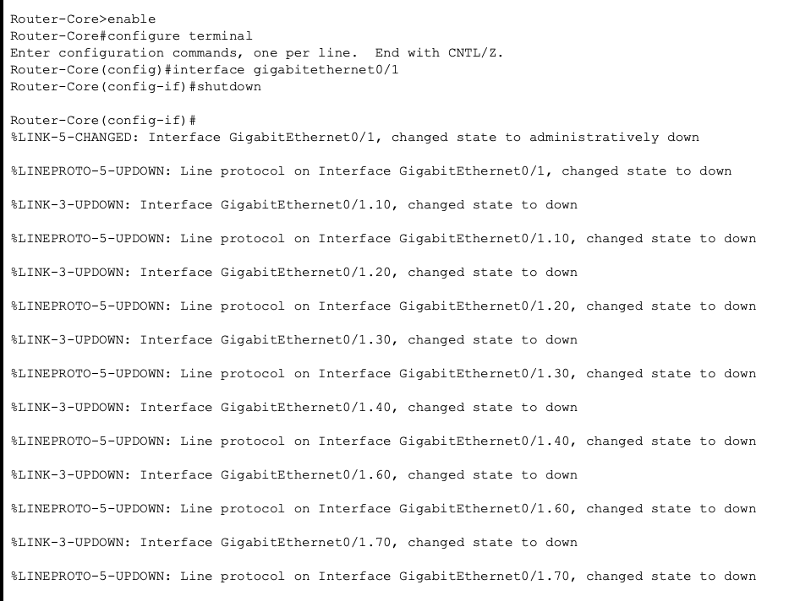
Figure 33. Extended run: Router-Core Gi0/1 shut down; Gi0/1 and sub-interfaces .10 to .70 (without .50) change to down.
The topology during the outage (Figure 34) shows red indicators on the Gi0/1 link between Router-Core and Core-Switch, while Router-Core Gi0/2 toward SWITCH-POS stays green.
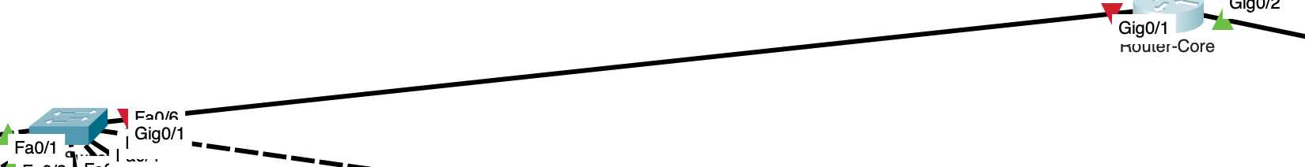
Figure 34. Extended run: topology during the outage, red indicators on the Gi0/1 link, Gi0/2 still green.
An office client confirmed that the outage was real: PC-FIN-01 could not reach its gateway 10.48.30.1 and lost all four packets (Figure 35).
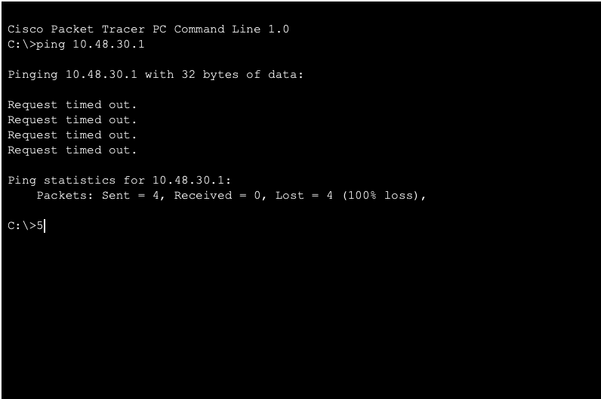
Figure 35. Extended run: PC-FIN-01 ping to 10.48.30.1 during the outage, 4/4 timeouts, 100% loss.
Gi0/1 was then restored with no shutdown, and the log shows the interface and all six office sub-interfaces returning to up (Figure 36).
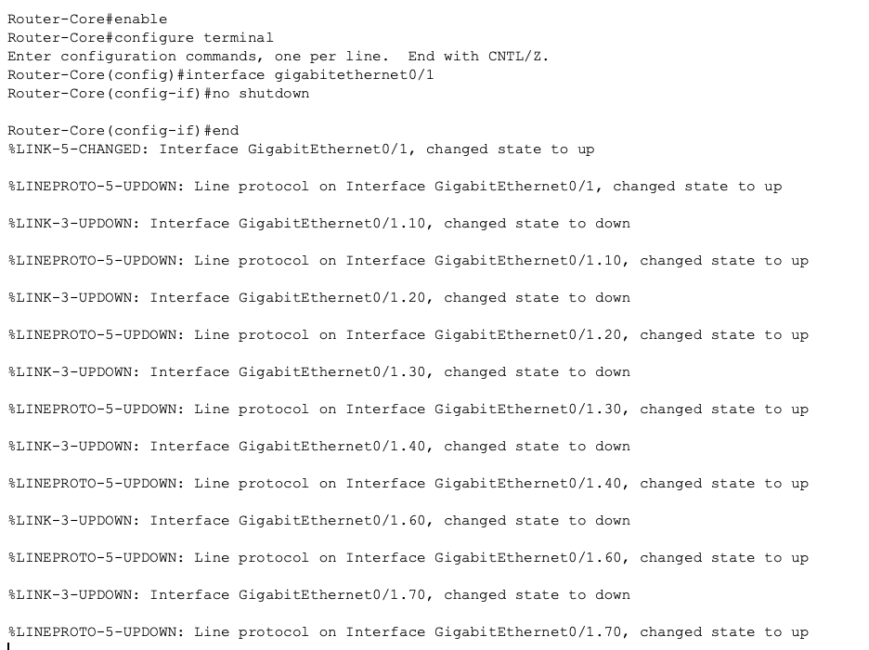
Figure 36. Extended run: Router-Core Gi0/1 restored with no shutdown; Gi0/1 and sub-interfaces .10 to .70 return to up.
What is not evidenced. This submission contains no captures of POS-01 pinging 203.0.113.10, either before or during the outage. The simulated internet path leaves Router-Core through Gi0/0 and does not use Gi0/1, so the design should allow POS to reach the test server during an office outage, but without those captures that result is not claimed. The conclusion in Section 7.4 stays limited to the POS gateway and peers.

7.4 Result and how it should be read
During a complete office LAN outage, POS-01 kept 0% loss to its gateway through Gi0/2 and to a peer terminal, while an office PC lost its gateway entirely. The gateway ping crosses the dedicated Gi0/2 link and proves the POS path through the router; the peer ping stays inside SWITCH-POS because both terminals are in the same VLAN, so it proves local POS switching rather than the router. Together they show the POS network is functional and independent of the office trunk. The result is stated as: POS retains connectivity to its dedicated gateway and peers when the office trunk fails. It is deliberately not stated as POS having full connectivity during an office failure, because during that failure it cannot reach office VLANs or the servers behind the shut-down trunk.

8 Limitations and scope notes
- Internet access is simulated via an implemented ISP segment. Router-Core holds a default route to Router-Edge (10.48.0.1); Router-Edge connects on its free interface GigabitEthernet0/1 to ISP-Router, which connects to Internet-Test-Server (203.0.113.10), as Figures 12a and 12b show. An office client reaches the test server by ICMP (0% loss, TTL 125) and by HTTP (Section 5.6), but POS external reachability during an office outage is not evidenced (Section 7.3). This is internet-style connectivity inside Packet Tracer only; it must not be reported as access to the real Internet.
- CR2 proves reachability to the POS gateway and peers only. POS cannot reach servers or office VLANs while the office trunk is down. The POS terminals needed a refreshed address after a link bounce (Section 6.6); if a terminal needs a new lease while Gi0/1 is down, the request cannot reach DHCP-SRV, which sits in VLAN 70 behind that trunk. A DHCP pool on Router-Core for 10.48.50.0/24, or static POS addresses, would remove that dependency and is the recommended hardening step. The simulated-internet path via Router-Edge does not use the office trunk by design, but a POS-to-internet test during the outage is not included (Section 7.3).
- Single points of failure. Router-Core, Core-Switch and the Gi0/1 trunk are each a single path for the office LAN, and all inter-VLAN traffic shares one link. This is a deliberate trade-off of the Router-on-a-Stick design at this scale.
- Guest wireless is built but not evidenced. AP-GUEST is cabled to SW-GUEST and LAPTOP-GUEST-01 is attached wirelessly, as Figure 1 shows, but this submission includes no capture of a guest client obtaining a 10.48.60.x address or reaching its gateway, so it is not claimed as verified.
- Screenshot limits. The route-table capture in Figure 6 is cut off before its last entries (explained in Section 5.2).

9 Evidence index and repository structure
All screenshots are stored in the evidence/ folder of the GitHub repository https://github.com/Ofentse2212/motsweding-network-infrastructure under the file names below.
Fig | Repository file | What it shows
1 | evidence/fig01-final-topology.png | Final operational topology
2 | evidence/fig02-port-labelled-topology.png | Topology with port labels
3 | evidence/fig03-initial-physical-build.png | Initial physical build, before configuration
4 | evidence/fig04-sw-fin-vlan-trunk.png | SW-FIN VLAN and trunk verification
5 | evidence/fig05-core-switch-vlan-trunk-cdp.png | Core-Switch VLANs and trunks, CDP mismatch visible
6 | evidence/fig06-router-core-roas-routes.png | Router-Core RoAS interfaces and routes
7 | evidence/fig07-same-vlan-ping.png | Same-VLAN ping, PC-FIN-01
8 | evidence/fig08-inter-vlan-ping.png | Inter-VLAN ping, PC-FIN-01 to VLAN 10
9 | evidence/fig09-web-server-access.png | HTTP access to WEB-SRV
10 | evidence/fig10-pc-it-01-first-attempts.png | PC-IT-01 first matrix attempts
11 | evidence/fig11-connectivity-matrix.png | PC-IT-01 final connectivity matrix
12 | evidence/fig12-cr1-pc-ops-10.png | CR1: PC-OPS-10 to WEB-SRV
12a | evidence/fig12a-internet-segment-topology.png | Simulated internet segment: Router-Edge, ISP-Router, Internet-Test-Server
12b | evidence/fig12b-router-edge-interfaces.png | Router-Edge free interface and route table before the internet link
13 | evidence/fig13-core-default-route.png | Router-Core default route to Router-Edge
14 | evidence/fig14-external-ping.png | Ping to simulated internet server 203.0.113.10
15 | evidence/fig15-external-web.png | Web page from simulated internet server
16 | evidence/fig16-dhcp-ipconfig.png | DHCP lease on PC-FIN-01 after the fixes
17 | evidence/fig17-server-switch-trunk.png | SERVER-SWITCH trunk after native VLAN fix
18 | evidence/fig18-core-switch-trunk-fixed.png | Core-Switch trunk after native VLAN fix
19 | evidence/fig19-pos-ping-t-invalid.png | POS-01 ping -t invalid, 100% loss
20 | evidence/fig20-switch-pos-vlan50-shutdown.png | SWITCH-POS VLAN 50 membership and deliberate shutdown
21 | evidence/fig21-pos-repeated-timeouts.png | POS-01 repeated timeouts
22 | evidence/fig22-switch-pos-recovery-cli.png | SWITCH-POS recovery CLI
23 | evidence/fig23-switch-pos-links-green.png | SWITCH-POS links green
24 | evidence/fig24-pos-ping-history.png | POS-01 ping history
25 | evidence/fig25-pos-gateway-reply.png | POS-01 gateway reply after recovery
26 | evidence/fig26-cr2-baseline-pos.png | CR2 baseline
27 | evidence/fig27-cr2-exec-mode-errors.png | Router-Core EXEC mode errors
28 | evidence/fig28-cr2-g0-1-shutdown.png | Router-Core Gi0/1 shutdown
29 | evidence/fig29-cr2-pos-still-online.png | POS still online during outage
30 | evidence/fig30-cr2-topology-outage.png | Topology during outage
31 | evidence/fig31-cr2-office-pc-fails.png | Office PC fails during outage
32 | evidence/fig32-cr2-restoration.png | Router-Core restoration
33 | evidence/fig33-ext-g0-1-shutdown.png | Extended run: Router-Core Gi0/1 shutdown
34 | evidence/fig34-ext-topology-outage.png | Extended run: topology during outage
35 | evidence/fig35-ext-office-pc-fails.png | Extended run: office PC fails during outage
36 | evidence/fig36-ext-restoration.png | Extended run: Gi0/1 restored

Recommended repository layout:
motsweding-network-infrastructure/
├── README.md
├── docs/
│ ├── Final_Submission_Report.docx
│ ├── configuration.md
│ ├── testing.md
│ └── troubleshooting.md
├── packet-tracer/
│ └── motsweding-network.pkt
├── configs/
│ ├── Router-Core.txt
│ ├── Core-Switch.txt
│ ├── SWITCH-POS.txt
│ ├── SW-FIN.txt
│ └── SERVER-SWITCH.txt
└── evidence/
└── fig01-... to fig36-... (.png)

10 Conclusion
The Motsweding network is implemented as designed. Router-on-a-Stick on Router-Core Gi0/1 routes six VLANs through 802.1Q sub-interfaces, a central DHCP server serves the office VLANs through relay, the web server answers across subnets, and the Operations department grew from two to ten workstations without any redesign. The client constraint was tested as a real failure: with the office trunk shut down, POS kept its gateway and peers while the office lost its gateway, and recovery was verified.
Equally important is what the evidence shows about the process. The faults that took longest were configuration mismatches between the two ends of a link (access against trunk, native VLAN 70 against 1, a 255.0.0.0 mask against a /24), and the most valuable correction was recognising that my first resilience test did not test the requirement. The final report keeps both the successes and these corrections, and it states the limits of the CR2 claim as carefully as the claim itself.

10.1 What I struggled with
The hardest part of this project was not building the network but making it work. The DHCP failure was the clearest example. A single symptom, a PC falling back to a 169.254.x.x address, hid four separate faults: VLANs and ports that were not set up, department uplinks configured as access ports, native VLAN mismatches on the trunks, and a 255.0.0.0 mask on the servers. Each fix looked as if it had changed nothing, because the next fault was still blocking the same path. That was frustrating, and at one point I deliberately set DHCP aside so the rest of the build could move forward, then came back to it with a proper checklist of the whole chain from PC to server and back.
Several smaller problems cost time as well. I applied an access-port range to the uplink instead of the PC ports, and Spanning Tree blocked the only path out of the switch. A native VLAN mismatch between Core-Switch and SERVER-SWITCH survived my first round of fixes, and I had to learn to read the wording of the CDP message to see which side was wrong. Duplicate DHCP leases made pings fail and made several PCs appear to share an address, and I have to be honest that I cleared them by restarting the service and renewing the clients rather than proving the exact cause. Packet Tracer itself added friction: a keyboard shortcut that placed Notes all over the workspace, a command prompt that rejects the -t flag, multiple commands on one line and pasted text, and a router left at the user prompt so that my shutdown command was treated as a host name to look up.
The most uncomfortable struggle was with my own testing. My first resilience test shut down the access port of POS-01. It produced a clean failure and a clean recovery, and it would have been easy to present it as proof of the client constraint. It was not. The office LAN stayed up the whole time, so nothing about the requirement had been tested. Admitting that, replacing the test with the real one, and keeping the old test in the record under its true name was harder than any of the configuration faults.

10.2 What this project taught me
Technically, I now understand Router-on-a-Stick as a system and not as a list of commands. One physical interface becomes several logical gateways, each sub-interface needs the right 802.1Q tag, and the switch trunk has to agree with the router on what is tagged, what is native and what is allowed. I learned why DHCP broadcasts need a relay to cross a router, why a subnet mask is part of the design and not a default to accept, why native VLANs must match at both ends of a trunk, and why Spanning Tree complains the moment a trunk meets an access port. I also learned to use small facts as evidence: a TTL of 127 proves a packet crossed exactly one router, and a single lost first packet is normally ARP and not a fault, while four timeouts in a row are a real problem.
The troubleshooting method mattered more than any single command. A network is a chain, and a fault anywhere in it looks the same from the end device, so the sensible approach is to work from the bottom up, check both ends of every link and change one thing at a time. Console and log messages are not noise; they usually name the problem and often the port. I also learned that most of my faults were mismatches between two ends of a link, so a mistake on one side is only visible when I look at the other.
On the design side, the POS constraint taught me to think in failure domains. Giving POS its own routed interface instead of a sub-interface meant that losing the office trunk could not take POS down with it, and the design only counts if a test can show that. I also learned that every design choice carries a trade-off: Router-on-a-Stick is simple and fits the assigned challenge, but all inter-VLAN traffic shares one link and Router-Core and Core-Switch remain single points of failure. A good addressing plan, with the VLAN number in the third octet and gateways always at .1, paid for itself when CR1 added eight workstations to Operations with no change to the router, the VLANs or the addressing.
Finally, the project taught me how to report honestly. A test is only meaningful if the failure it depends on really happened, which is why the CR2 test also shows an office PC losing its gateway. A claim should be stated at the strength the evidence supports, which is why the result says POS keeps its gateway and peers, not that POS has full connectivity during an office failure. Keeping the failed attempts, the corrections and the limitations in the report made it more trustworthy, not weaker.

10.3 What I would do differently
If I built this network again I would configure every switch uplink from one tested template, verify each stage with show commands before moving to the next, and set subnet masks explicitly instead of trusting defaults. I would save screenshots and configurations as I go, with the names I will use in the repository, instead of reconstructing evidence afterwards. I would write the test plan for each requirement before building, so that I test the requirement and not a convenient substitute. With more time I would add a DHCP pool on Router-Core for the POS subnet so that terminals can renew leases during an office outage, capture evidence for the guest wireless client, and remove the single points of failure with a second link or a redundant core.

10.4 Final reflection
I started this project thinking the work was configuring devices. I finished it understanding that the work is knowing how the pieces depend on each other, finding the broken link when everything looks the same from the outside, and proving what was built with evidence I can defend. The network works, but what I value most is that I can now explain why it works, why it failed earlier, and exactly how far my claims go.

